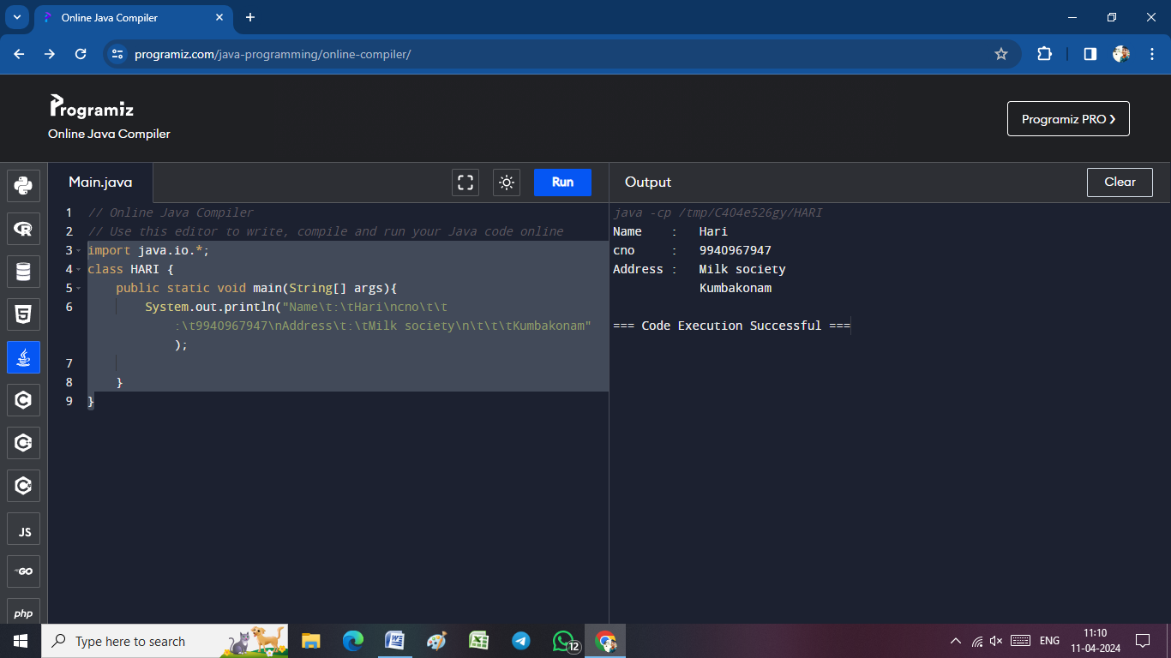import java.io.*;

class HARI {

public static void main(String[] args){

System.out.println("Name\t:\tHari\ncno\t\t:\t9940967947\nAddress\t:\tMilk society\n\t\t\tKumbakonam");

}

}

import java.io.*;

class HARI {

public static void main(String[] args){

System.out.println("---------------------------------\n| Name\t\t:\tHari\t\t\t|\n| cno\t\t:\t9940967947\t\t|\n| Address\t:\tMilk society\t|\n| \t\t\t\tKumbakonam\t\t|\n---------------------------------");

}

}

­­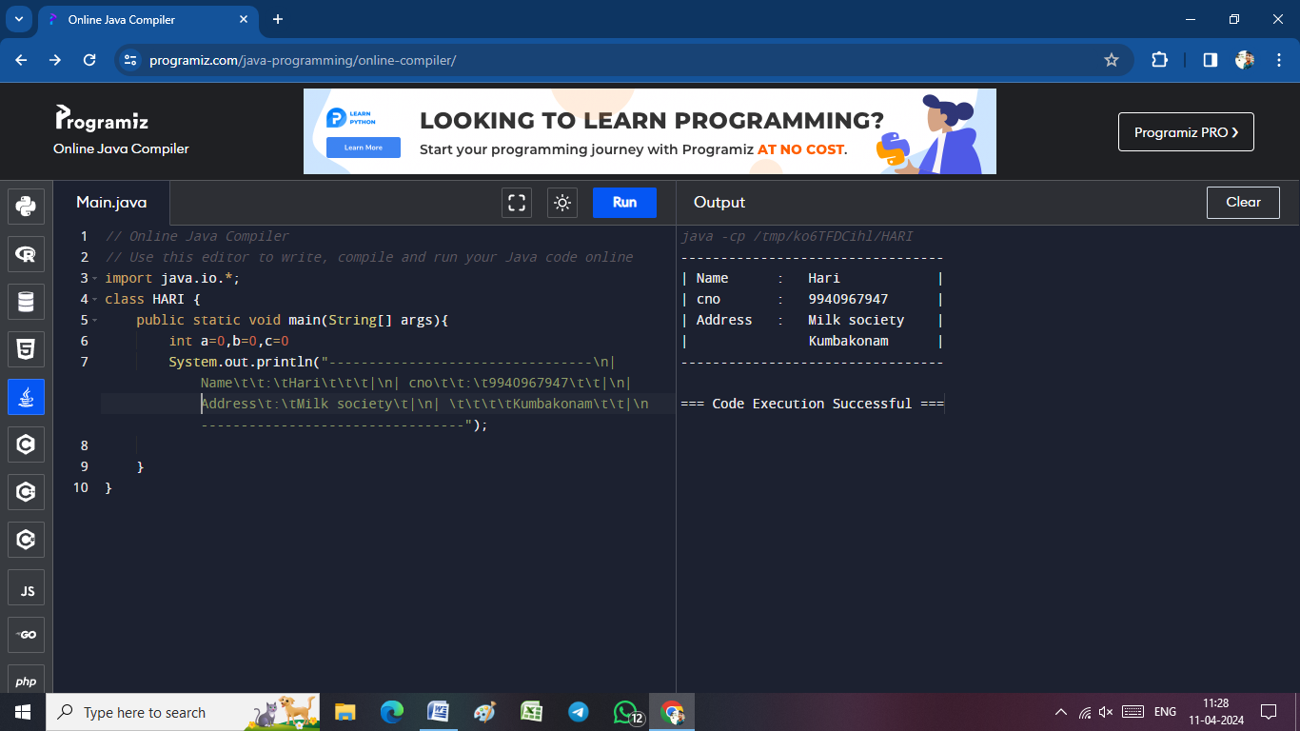

import java.io.*;

class HARI {

public static void main(String[] args) throws IOException {

int a=0,b=0,c=0;

DataInputStream in=new DataInputStream(System.in);

System.out.println("Enter A value =>");

a=Integer.parseInt(in.readLine());

System.out.println("Enter B value =>");

b=Integer.parseInt(in.readLine());

c=a+b;

System.out.println("Adding of two Numbers is => "+c);

}

}

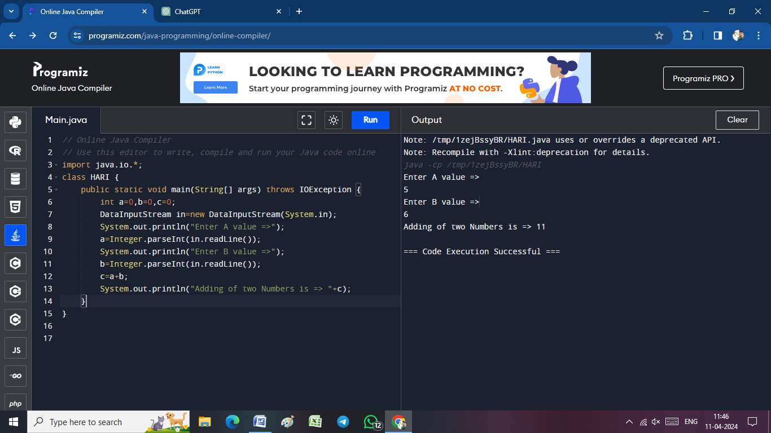

import java.io.*;

class HARI {

public static void main(String[] args) throws IOException {

int tamil=0,english=0,maths=0,total=0;

float avg=0;

DataInputStream in=new DataInputStream(System.in);

System.out.println("Enter Tamil Mark =>");

tamil=Integer.parseInt(in.readLine());

System.out.println("Enter English Mark =>");

english=Integer.parseInt(in.readLine());

System.out.println("Enter Maths Mark =>");

maths=Integer.parseInt(in.readLine());

total=tamil+english+maths;

avg=total/3;

System.out.println("Answer:-\n------\n\tTamil Marks\t\t=>\t"+ tamil+"\n\tEnglish Marks\t=>\t"+english+"\n\tMaths Marks\t\t=>\t"+maths+"\n\tTotal Marks \t=> \t"+ total+"\n\tAverage Marks \t=> \t"+ avg);

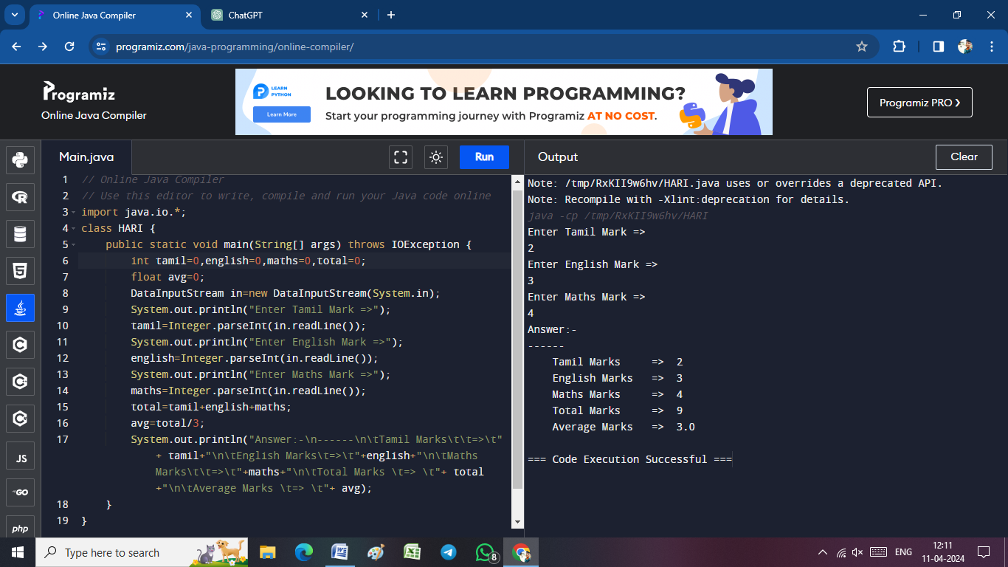 }

}

import java.io.*;

class HARI {

public static void main(String[] args) throws IOException {

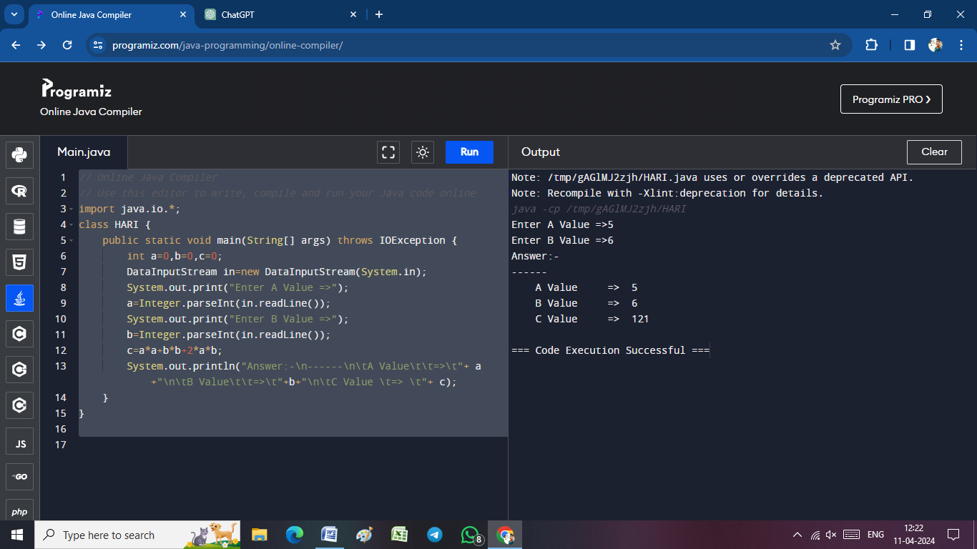 int a=0,b=0,c=0;

DataInputStream in=new DataInputStream(System.in);

System.out.print("Enter A Value =>");

a=Integer.parseInt(in.readLine());

System.out.print("Enter B Value =>");

b=Integer.parseInt(in.readLine());

c=a*a+b*b+2*a*b;

System.out.println("Answer:-\n------\n\tA Value\t\t=>\t"+ a+"\n\tB Value\t\t=>\t"+b+"\n\tC Value \t=> \t"+ c);

}

}

import java.io.*;

class HARI {

public static void main(String[] args) throws IOException {

String pname;

float quantity=0,tax=0,price=0;

float taxaverage,taxamount;

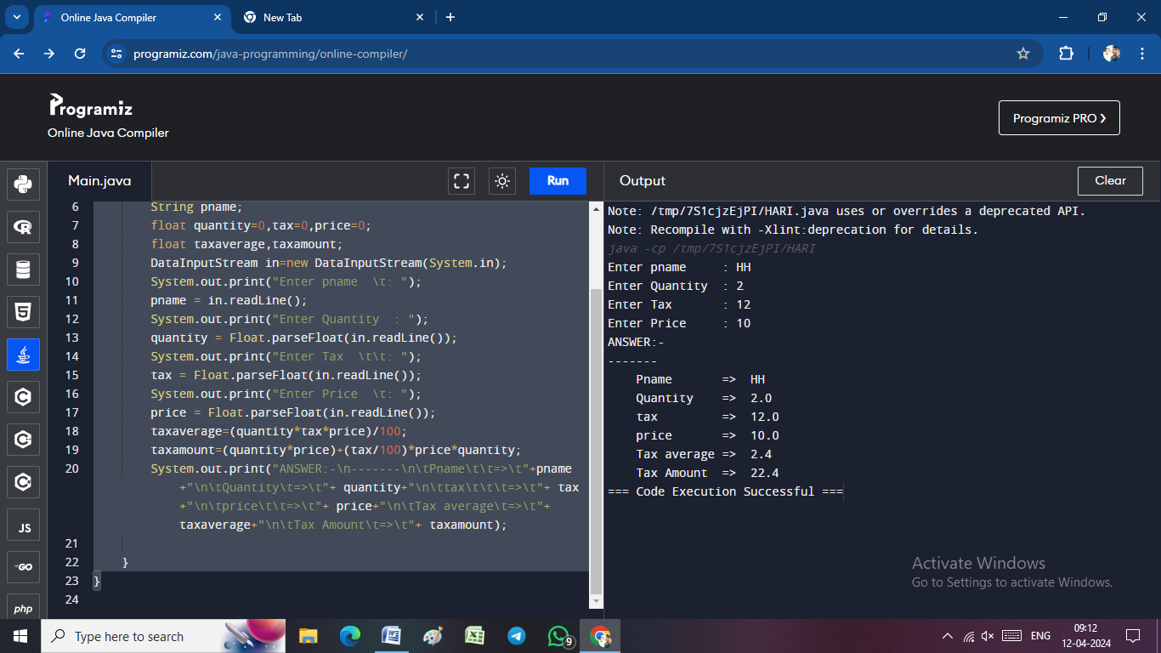 DataInputStream in=new DataInputStream(System.in);

System.out.print("Enter pname \t: ");

pname = in.readLine();

System.out.print("Enter Quantity : ");

quantity = Float.parseFloat(in.readLine());

System.out.print("Enter Tax \t\t: ");

tax = Float.parseFloat(in.readLine());

System.out.print("Enter Price \t: ");

price = Float.parseFloat(in.readLine());

taxaverage=(quantity*tax*price)/100;

taxamount=(quantity*price)+(tax/100)*price*quantity;

System.out.print("ANSWER:-\n-------\n\tPname\t\t=>\t"+pname+"\n\tQuantity\t=>\t"+ quantity+"\n\ttax\t\t\t=>\t"+ tax+"\n\tprice\t\t=>\t"+ price+"\n\tTax average\t=>\t"+ taxaverage+"\n\tTax Amount\t=>\t"+ taxamount);

}

}

import java.io.*;

class Student {

public static void main(String[] args) throws IOException {

int subject1 = 0, subject2 = 0, subject3 = 0, subject4=0, subject5 = 0, total;

float avg = 0;

String name;

DataInputStream in = new DataInputStream(System.in);

System.out.print("Enter Your Name =>");

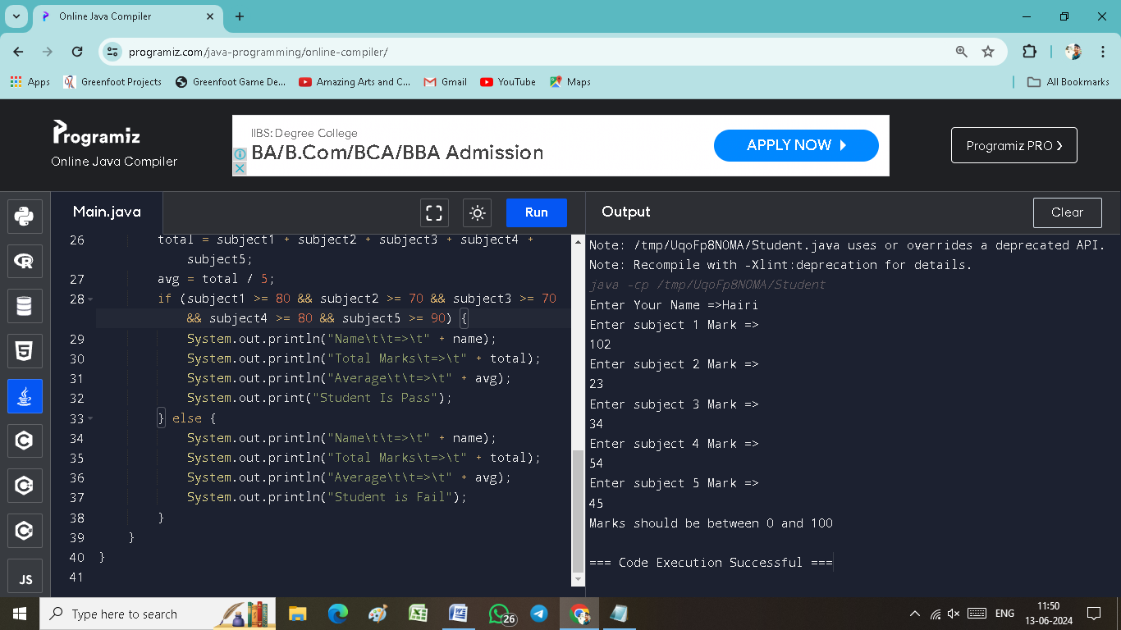 name = in.readLine();

System.out.println("Enter subject 1 Mark =>");

subject1 = Integer.parseInt(in.readLine());

System.out.println("Enter subject 2 Mark =>");

subject2 = Integer.parseInt(in.readLine());

System.out.println("Enter subject 3 Mark =>");

subject3 = Integer.parseInt(in.readLine());

System.out.println("Enter subject 4 Mark =>");

subject4 = Integer.parseInt(in.readLine());

System.out.println("Enter subject 5 Mark =>");

subject5 = Integer.parseInt(in.readLine());

if (subject1 < 0 || subject1 > 100 || subject2 < 0 || subject2 > 100 || subject3 < 0 || subject3 > 100 ||

subject4 < 0 || subject4 > 100 || subject5 < 0 || subject5 > 100) {

System.out.println("Marks should be between 0 and 100");

return;

}

total = subject1 + subject2 + subject3 + subject4 + subject5;

avg = total / 5;

if (subject1 >= 80 && subject2 >= 70 && subject3 >= 70 && subject4 >= 80 && subject5 >= 90) {

System.out.println("Name\t\t=>\t" + name);

System.out.println("Total Marks\t=>\t" + total);

System.out.println("Average\t\t=>\t" + avg);

System.out.print("Student Is Pass");

} else {

System.out.println("Name\t\t=>\t" + name);

System.out.println("Total Marks\t=>\t" + total);

System.out.println("Average\t\t=>\t" + avg);

System.out.println("Student is Fail");

}

}

}

import java.io.*;

class HARI {

public static void main(String[] args) throws IOException {

int a=0,b=0,c=0;

DataInputStream in=new DataInputStream(System.in);

System.out.println("Enter A value =>");

a=Integer.parseInt(in.readLine());

System.out.println("Enter B value =>");

b=Integer.parseInt(in.readLine());

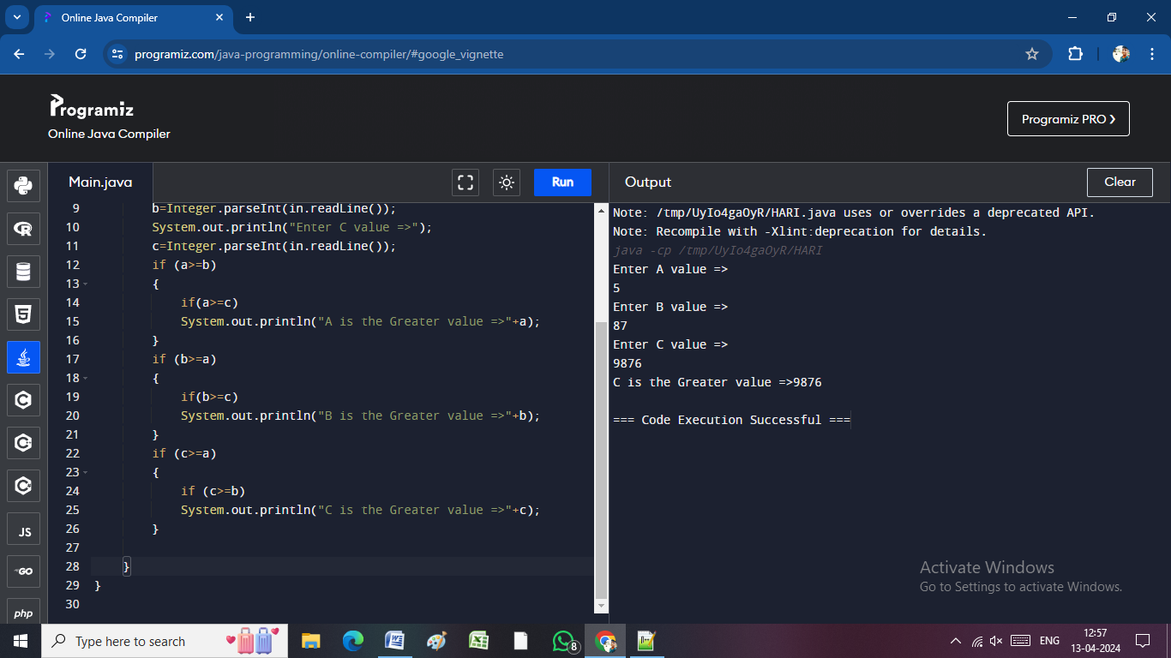 System.out.println("Enter C value =>");

c=Integer.parseInt(in.readLine());

if (a>=b)

{

if(a>=c)

System.out.println("A is the Greater value =>"+a);

}

if (b>=a)

{

if(b>=c)

System.out.println("B is the Greater value =>"+b);

}

if (c>=a)

{

if (c>=b)

System.out.println("C is the Greater value =>"+c);

}

}

}

import java.io.*;

class HARI {

public static void main(String[] args) throws IOException {

int tamil=0,english=0,maths=0,total=0;

float avg=0;

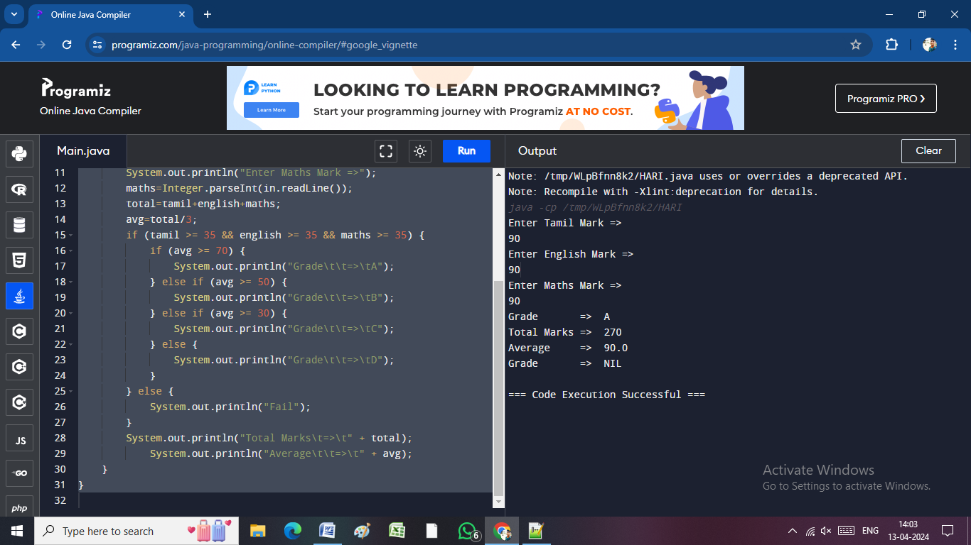 DataInputStream in=new DataInputStream(System.in);

System.out.println("Enter Tamil Mark =>");

tamil=Integer.parseInt(in.readLine());

System.out.println("Enter English Mark =>");

english=Integer.parseInt(in.readLine());

System.out.println("Enter Maths Mark =>");

maths=Integer.parseInt(in.readLine());

total=tamil+english+maths;

avg=total/3;

if (tamil >= 35 && english >= 35 && maths >= 35) {

if (avg >= 70) {

System.out.println("Grade\t\t=>\tA");

} else if (avg >= 50) {

System.out.println("Grade\t\t=>\tB");

} else if (avg >= 30) {

System.out.println("Grade\t\t=>\tC");

} else {

System.out.println("Grade\t\t=>\tD");

}

} else {

System.out.println("Fail");

}

System.out.println("Total Marks\t=>\t" + total);

System.out.println("Average\t\t=>\t" + avg);

}

}

import java.io.*;

class HARI {

public static void main(String[] args) throws IOException {

int a=0,b=0,c=0;

DataInputStream in=new DataInputStream(System.in);

System.out.println("Enter A value =>");

a=Integer.parseInt(in.readLine());

System.out.println("Enter B value =>");

b=Integer.parseInt(in.readLine());

System.out.println("Enter C value =>");

c=Integer.parseInt(in.readLine());

if(a>=b && a>=c)

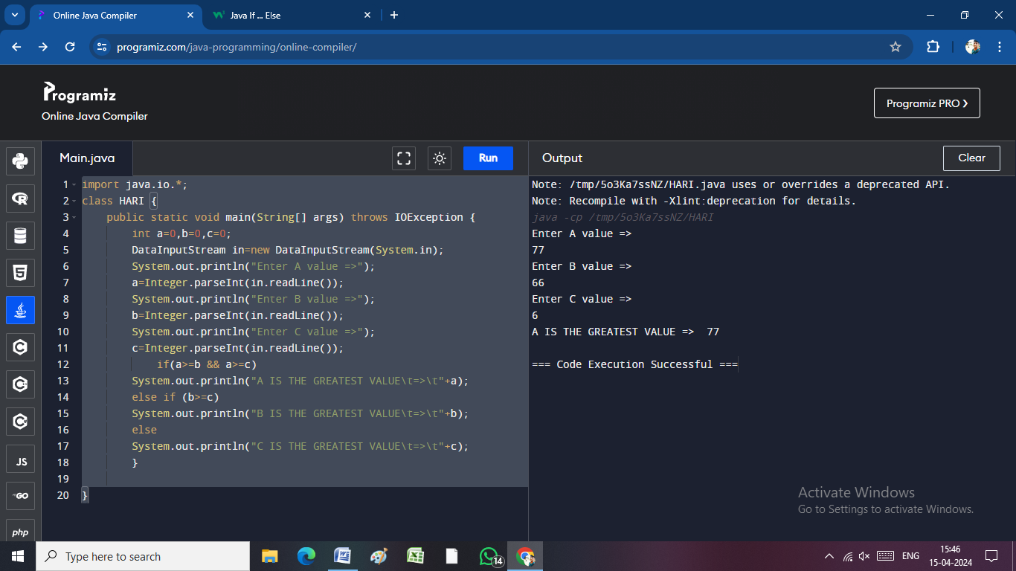 System.out.println("A IS THE GREATEST VALUE\t=>\t"+a);

else if (b>=c)

System.out.println("B IS THE GREATEST VALUE\t=>\t"+b);

else

System.out.println("C IS THE GREATEST VALUE\t=>\t"+c);

}

}

import java.io.*;

class HARI {

public static void main(String[] args) throws IOException {

int a=0,b=0,c=0,d=0,e=0;

DataInputStream in=new DataInputStream(System.in);

System.out.println("Enter A value =>");

a=Integer.parseInt(in.readLine());

System.out.println("Enter B value =>");

b=Integer.parseInt(in.readLine());

System.out.println("Enter C value =>");

c=Integer.parseInt(in.readLine());

System.out.println("Enter D value =>");

d=Integer.parseInt(in.readLine());

System.out.println("Enter E value =>");

e=Integer.parseInt(in.readLine());

if(a>=b && a>=c && a>=d && a>=e)

System.out.println("A IS THE GREATEST VALUE\t=>\t"+a);

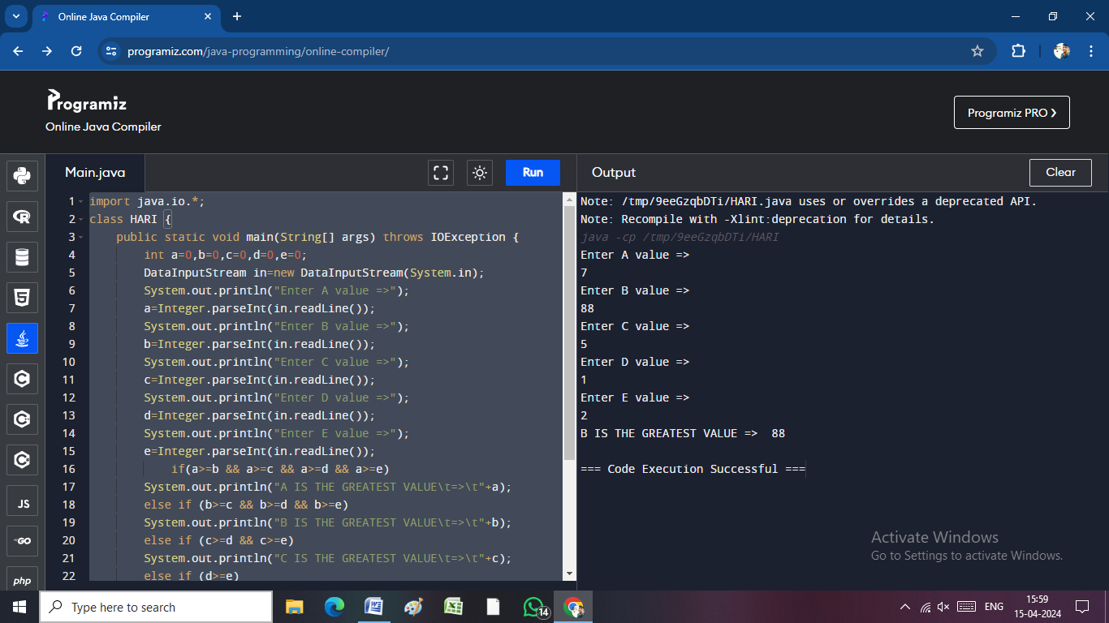 else if (b>=c && b>=d && b>=e)

System.out.println("B IS THE GREATEST VALUE\t=>\t"+b);

else if (c>=d && c>=e)

System.out.println("C IS THE GREATEST VALUE\t=>\t"+c);

else if (d>=e)

System.out.println("D IS THE GREATEST VALUE\t=>\t"+d);

else

System.out.println("E IS THE GREATEST VALUE\t=>\t"+e);

}

}

import java.io.*;

class HARI {

public static void main(String[] args) throws IOException {

int tamil=0,english=0,maths=0,total=0;

float avg=0;

String Name;

DataInputStream in=new DataInputStream(System.in);

System.out.print("Enter Your Name =>");

Name=in.readLine();

System.out.println("Enter Tamil Mark =>");

tamil=Integer.parseInt(in.readLine());

System.out.println("Enter English Mark =>");

english=Integer.parseInt(in.readLine());

System.out.println("Enter Maths Mark =>");

maths=Integer.parseInt(in.readLine());

total=tamil+english+maths;

avg=total/3;

if (tamil >= 70 && english >= 90 && maths >= 90)

{

System.out.println("Name\t\t=>\t" + Name);

System.out.println("Total Marks\t=>\t" + total);

System.out.println("Average\t\t=>\t" + avg);

System.out.print("Student Is Pass");

}

else {

System.out.println("Name\t\t=>\t" + Name);

System.out.println("Total Marks\t=>\t" + total);

System.out.println("Average\t\t=>\t" + avg);

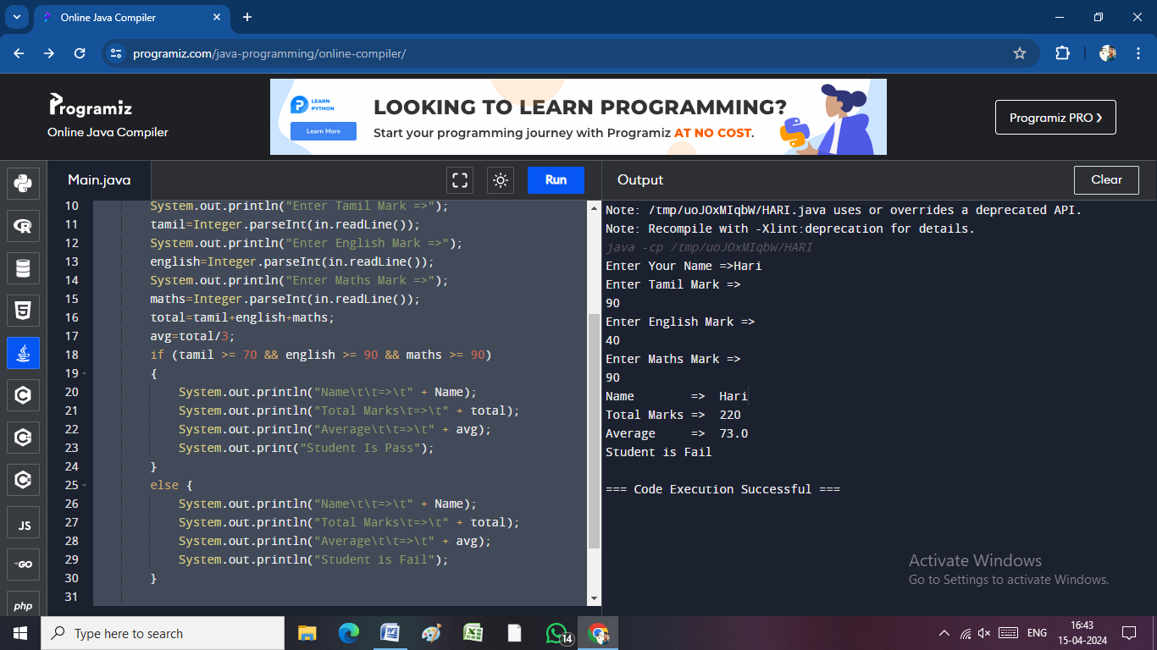 System.out.println("Student is Fail");

}

}

}

import java.io.*;

class HARI {

public static void main(String[] args) throws IOException {

int EBNUMBER=0,PR=0,CR=0,TU=0,cost=0,Tamount=0;

DataInputStream in=new DataInputStream(System.in);

System.out.print("Enter Your EB NUMBER =>");

EBNUMBER=Integer.parseInt(in.readLine());

System.out.println("Enter Previous Reading =>");

PR=Integer.parseInt(in.readLine());

System.out.println("Enter Current Reading =>");

CR=Integer.parseInt(in.readLine());

TU=(CR-PR);

if (TU<=100){

cost=1;

Tamount=(TU*cost);

}

else if (TU<=200){

cost=2;

Tamount=(TU*cost);

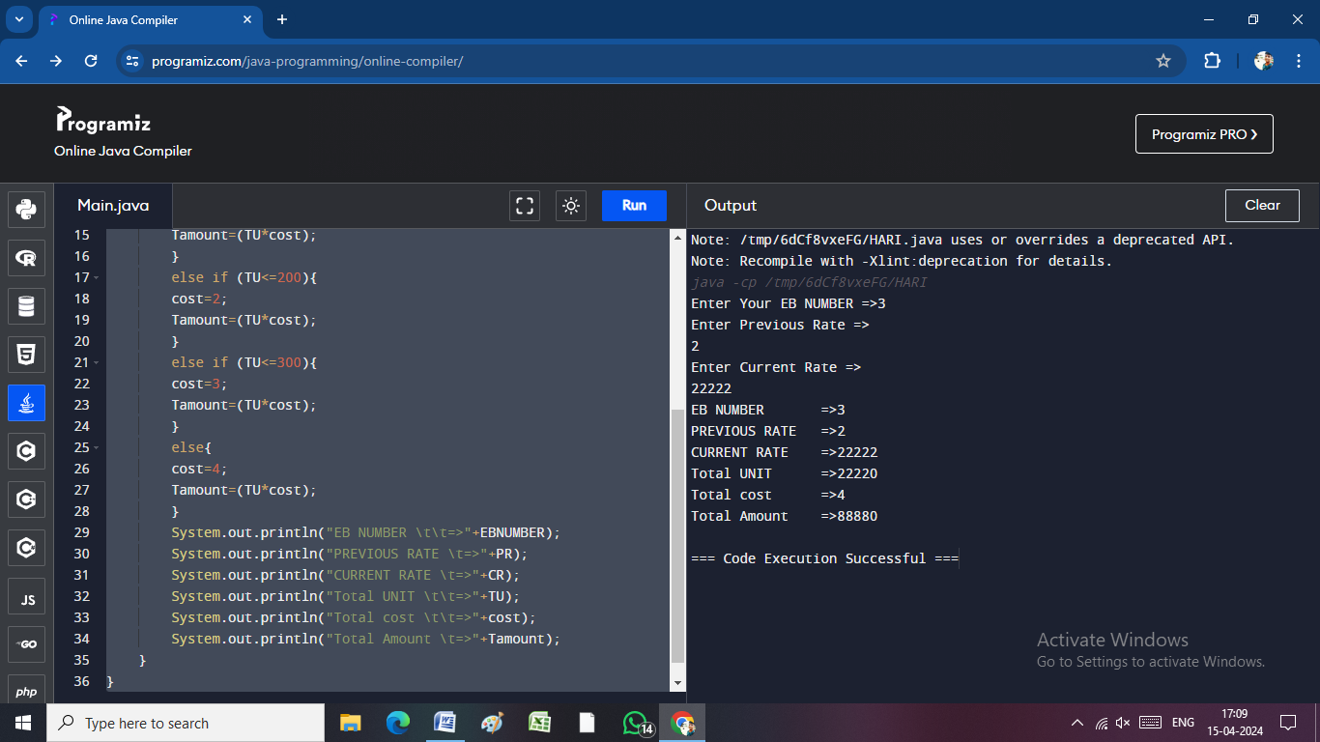 }

else if (TU<=300){

cost=3;

Tamount=(TU*cost);

}

else{

cost=4;

Tamount=(TU*cost);

}

System.out.println("EB NUMBER \t\t=>"+EBNUMBER);

System.out.println("PREVIOUS RATE \t=>"+PR);

System.out.println("CURRENT RATE \t=>"+CR);

System.out.println("Total UNIT \t\t=>"+TU);

System.out.println("Total cost \t\t=>"+cost);

System.out.println("Total Amount \t=>"+Tamount);

}

}

**SWITCH CASE : 1**

import java.io.*;

public class switchcase

{

public static void main(String[] args)throws IOException {

DataInputStream in=new DataInputStream(System.in);

double a=0,b=0,d=0,e=0,f=0;

int c=0;

System.out.println("ENTER FIRST VALUE");

a=Double.parseDouble(in.readLine());

System.out.println("ENTER SECOND VALUE");

b=Double.parseDouble(in.readLine());

System.out.println("SELECT ANY OPTION");

System.out.println("1.Addition");

System.out.println("2.Subraction");

System.out.println("3.MUL");

System.out.println("4.DIV");

c=Integer.parseInt(in.readLine());

switch(c){

case 1:

d=a+b;

System.out.println("Addition Value =>\t"+d);

break;

case 2:

e=a-b;

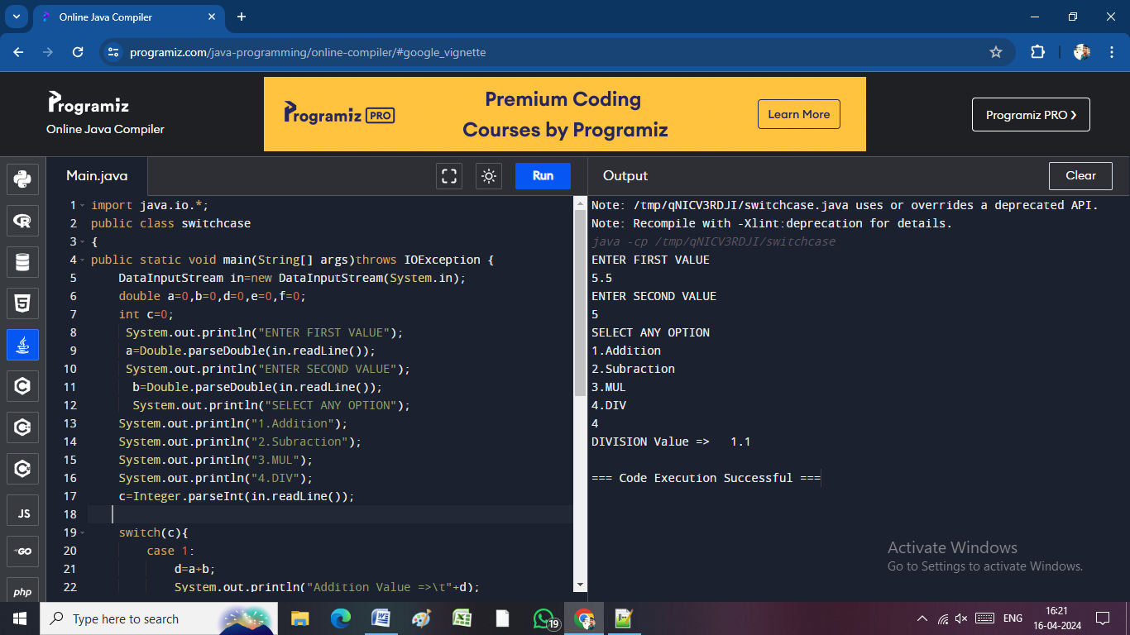 System.out.println("Subraction Value =>\t"+e);

break;

case 3:

f=a*b;

System.out.println("Multiplication Value =>\t"+f);

break;

case 4:

f=a/b;

System.out.println("DIVISION Value =>\t"+f);

break;

default:

System.out.println("Please Enter Valid Number");

}

}

}

**SWITCH CASE : 2**

import java.io.*;

public class switchcase

{

public static void main(String[] args)throws IOException {

DataInputStream in=new DataInputStream(System.in);

int a=0;

System.out.println("ENTER NUMBER BETWEEN 1-12");

a=Integer.parseInt(in.readLine());

switch(a){

case 1:

System.out.println("JANUARY");

break;

case 2:

System.out.println("FEBRUARY");

break;

case 3:

System.out.println("MARCH");

break;

case 4:

System.out.println("APRIL");

break;

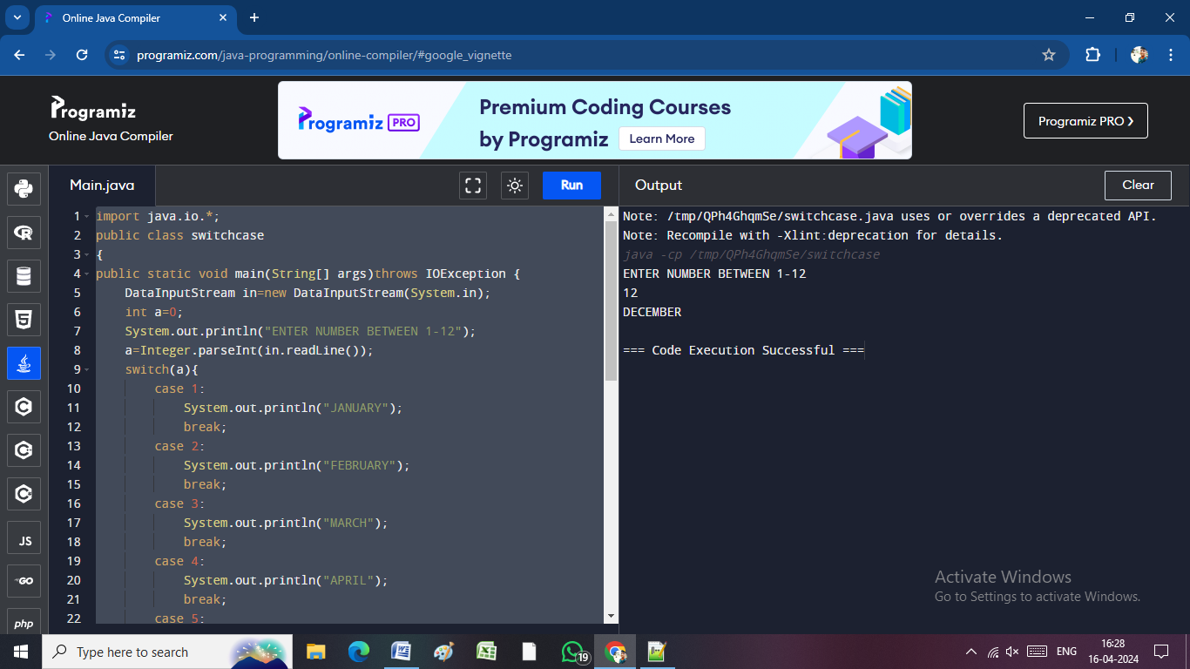 case 5:

System.out.println("MAY");

break;

case 6:

System.out.println("JUNE");

break;

case 7:

System.out.println("JULY");

break;

case 8:

System.out.println("AUGUST");

break;

case 9:

System.out.println("SEPTEMBER");

break;

case 10:

System.out.println("OCTOBER");

break;

case 11:

System.out.println("NOVEMBER");

break;

case 12:

System.out.println("DECEMBER");

break;

default:

System.out.println("Please Enter Valid Number");

}

}

}

**FOR LOOP:**

class Main {

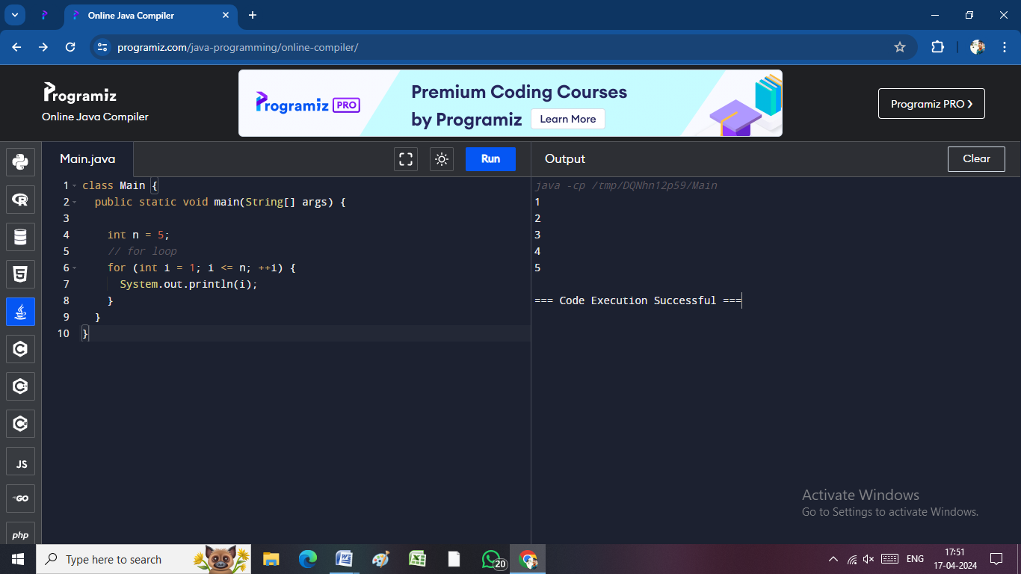 public static void main(String[] args) {

int n = 5;

// for loop

for (int i = 1; i <= n; ++i) {

System.out.println(i);

}

}

}

import java.io.*;

public class SwitchCase {

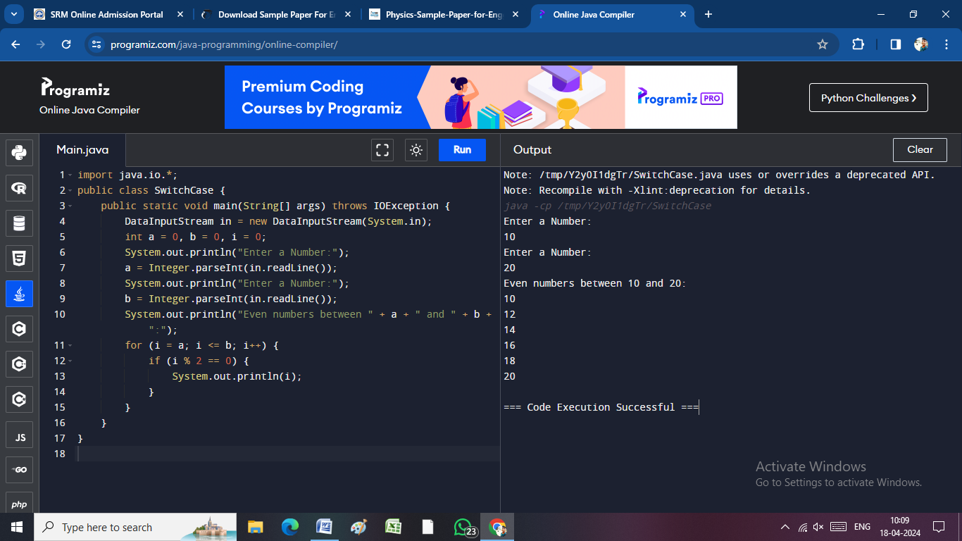 public static void main(String[] args) throws IOException {

DataInputStream in = new DataInputStream(System.in);

int a = 0, b = 0, i = 0;

System.out.println("Enter a Number:");

a = Integer.parseInt(in.readLine());

System.out.println("Enter a Number:");

b = Integer.parseInt(in.readLine());

System.out.println("Even numbers between " + a + " and " + b + ":");

for (i = a; i <= b; i++) {

if (i % 2 == 0) {

System.out.println(i);

}

}

}

}

**WHILE :**

import java.io.*;

public class switchcase

{

public static void main(String[] args)throws IOException

{

DataInputStream in=new DataInputStream(System.in);

int a=0,b=0;

System.out.println("Enter a Number:");

a=Integer.parseInt(in.readLine());

System.out.println("Enter a Number:");

b=Integer.parseInt(in.readLine());

while(a<b)

{

System.out.println(a);

a++;

}

}

}

**DO….WHILE:**

import java.util.Scanner;

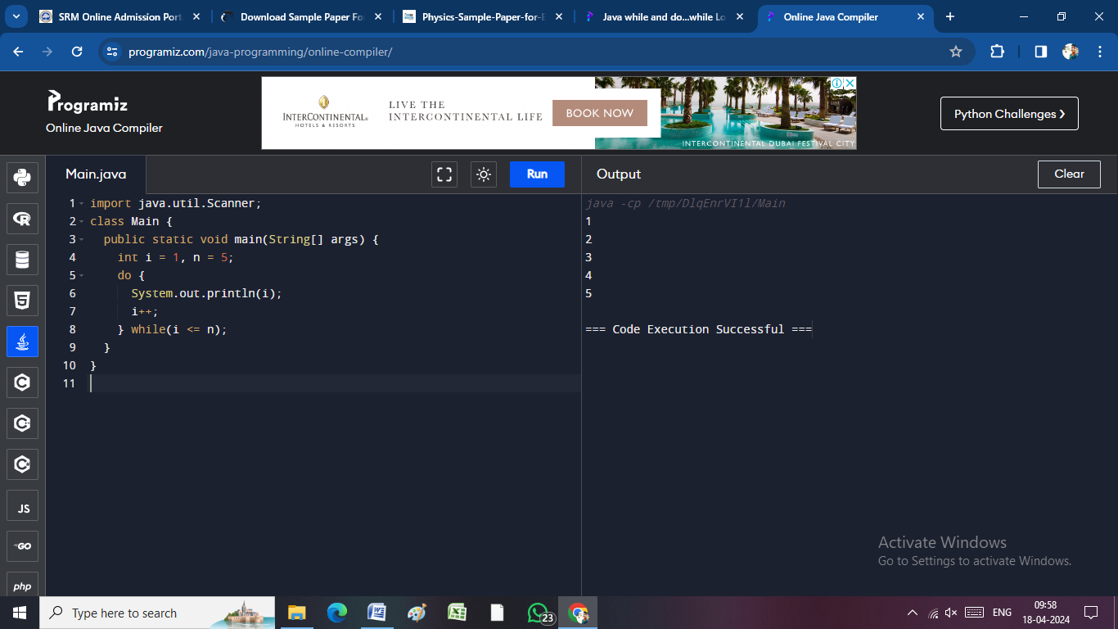class Main {

public static void main(String[] args) {

int i = 1, n = 5;

do {

System.out.println(i);

i++;

} while(i <= n);

}

}

**ARRAY :**

import java.io.*;

public class SwitchCase {

public static void main(String[] args) throws IOException {

DataInputStream in = new DataInputStream(System.in);

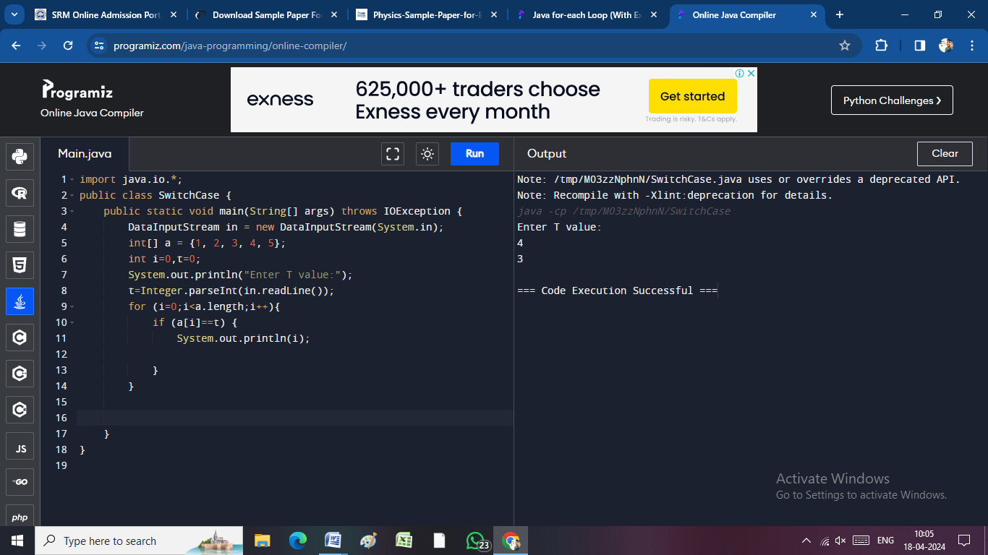 int[] a = {1, 2, 3, 4, 5};

int i=0,t=0;

System.out.println("Enter T value:");

t=Integer.parseInt(in.readLine());

for (i=0;i<a.length;i++){

if (a[i]==t) {

System.out.println(i);

}

}

}

}

import java.io.*;

public class SwitchCase {

public static void main(String[] args) throws IOException {

DataInputStream in = new DataInputStream(System.in);

int a=0,i=0,b=0;

System.out.println("Enter a Number:");

a=Integer.parseInt(in.readLine());

for (i=1;i<=a;i++){

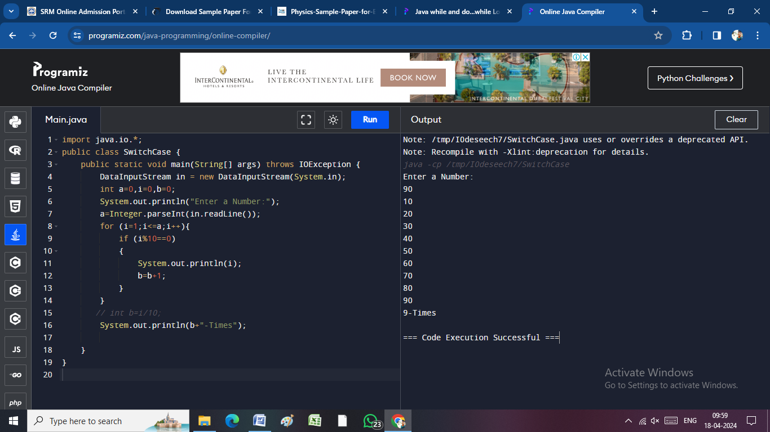 if (i%10==0)

{

System.out.println(i);

b=b+1;

}

}

// int b=i/10;

System.out.println(b+"-Times");

}

}

import java.io.*;

public class SwitchCase {

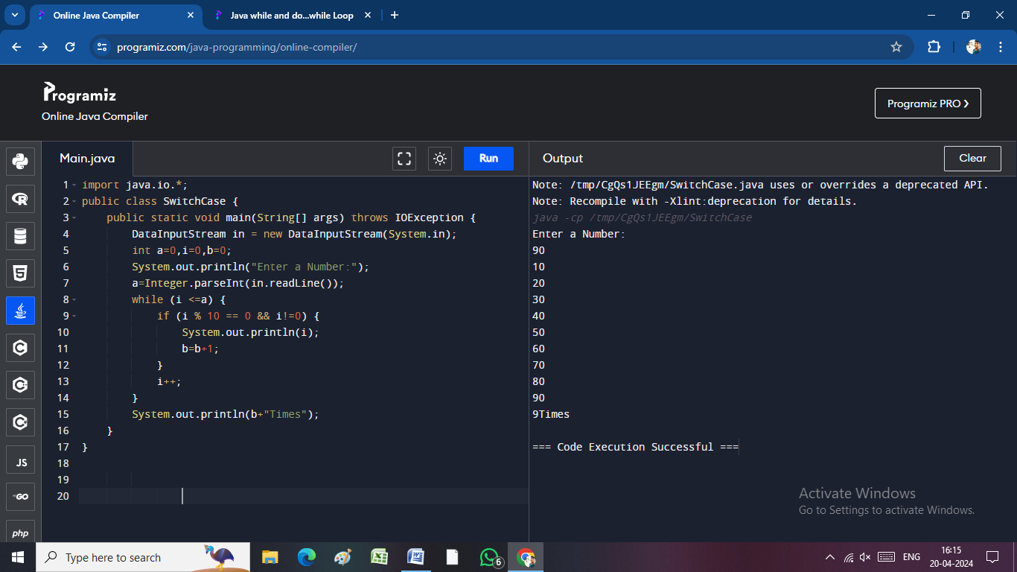 public static void main(String[] args) throws IOException {

DataInputStream in = new DataInputStream(System.in);

int a=0,i=0,b=0;

System.out.println("Enter a Number:");

a=Integer.parseInt(in.readLine());

while (i <=a) {

if (i % 10 == 0 && i!=0) {

System.out.println(i);

b=b+1;

}

i++;

}

System.out.println(b+"Times");

}

}

import java.io.*;

public class SwitchCase {

public static void main(String[] args) throws IOException {

DataInputStream in = new DataInputStream(System.in);

int a = 0, i = 0, b = 0;

System.out.println("Enter a Number:");

a = Integer.parseInt(in.readLine());

do {

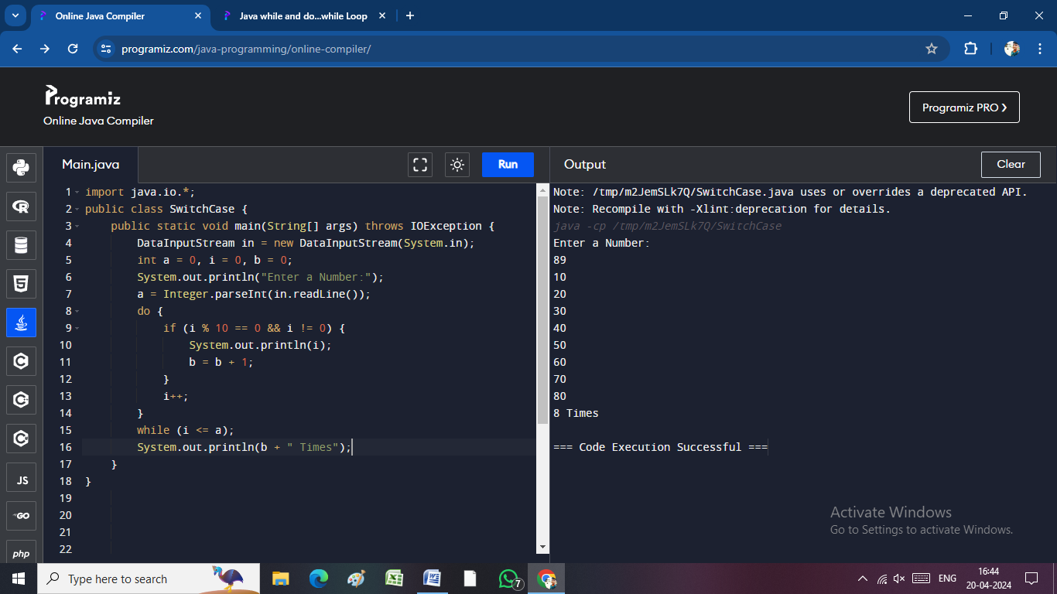 if (i % 10 == 0 && i != 0) {

System.out.println(i);

b = b + 1;

}

i++;

}

while (i <= a);

System.out.println(b + " Times");

}

}

import java.io.*;

public class SwitchCase {

public static void main(String[] args) throws IOException {

DataInputStream in = new DataInputStream(System.in);

int English, Tamil, Maths, total;

for (int j = 0; j < 2; j++) {

System.out.println("Enter Your Name:");

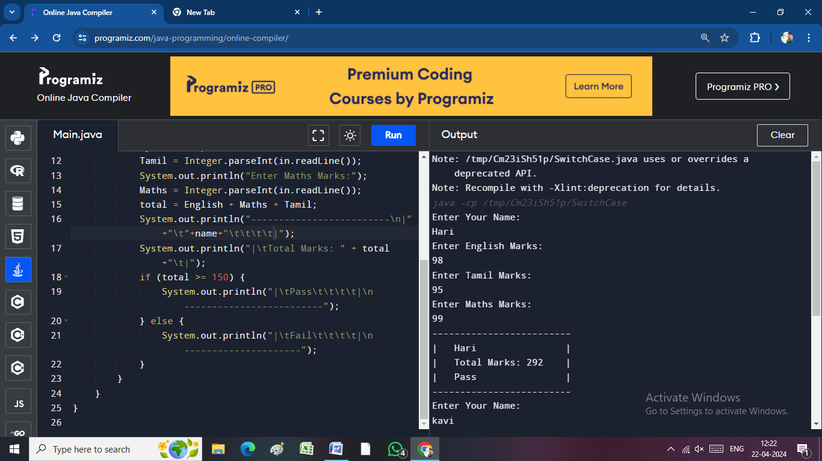 String name = in.readLine();

System.out.println("Enter English Marks:");

English = Integer.parseInt(in.readLine());

System.out.println("Enter Tamil Marks:");

Tamil = Integer.parseInt(in.readLine());

System.out.println("Enter Maths Marks:");

Maths = Integer.parseInt(in.readLine ());

total = English + Maths + Tamil;

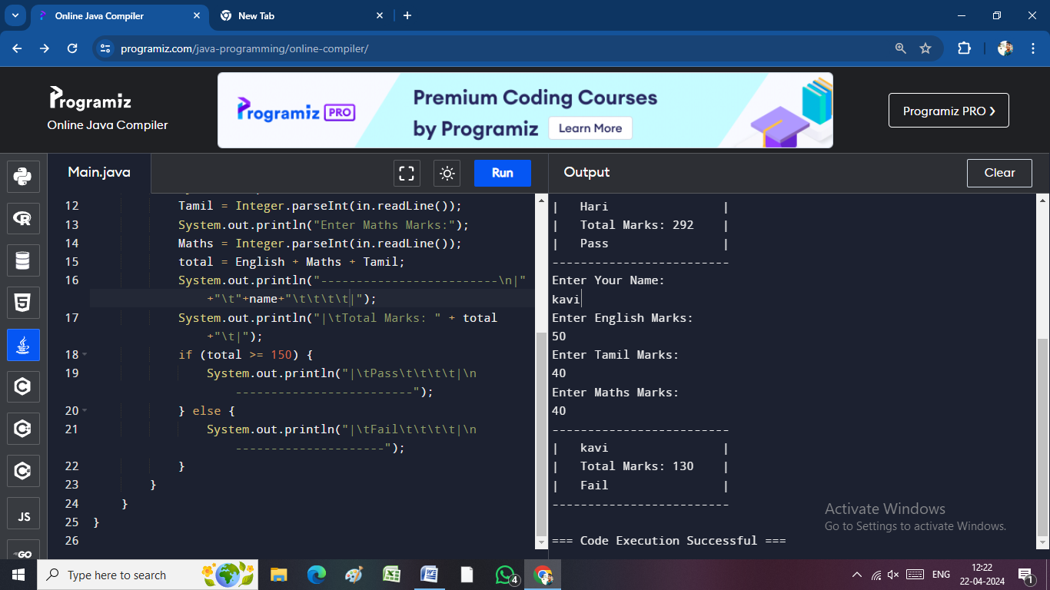 System.out.println("-------------------------\n|"+"\t"+name+"\t\t\t\t\t|");

System.out.println("|\tTotal Marks: " + total+"\t|");

if (total >= 150) {

System.out.println("|\tPass\t\t\t\t|\n-------------------------");

} else {

System.out.println("|\tFail\t\t\t\t|\n---------------------");

}

}

}

}

**ARRAY:**

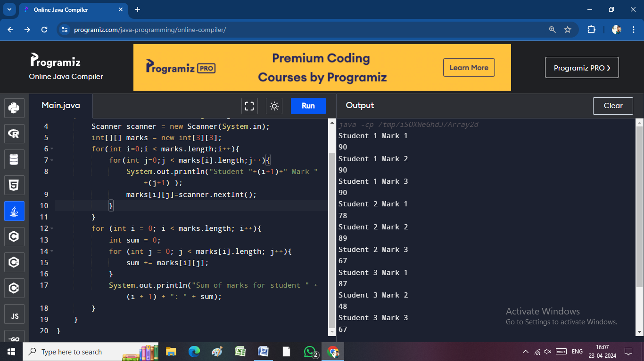import java.util.Scanner;

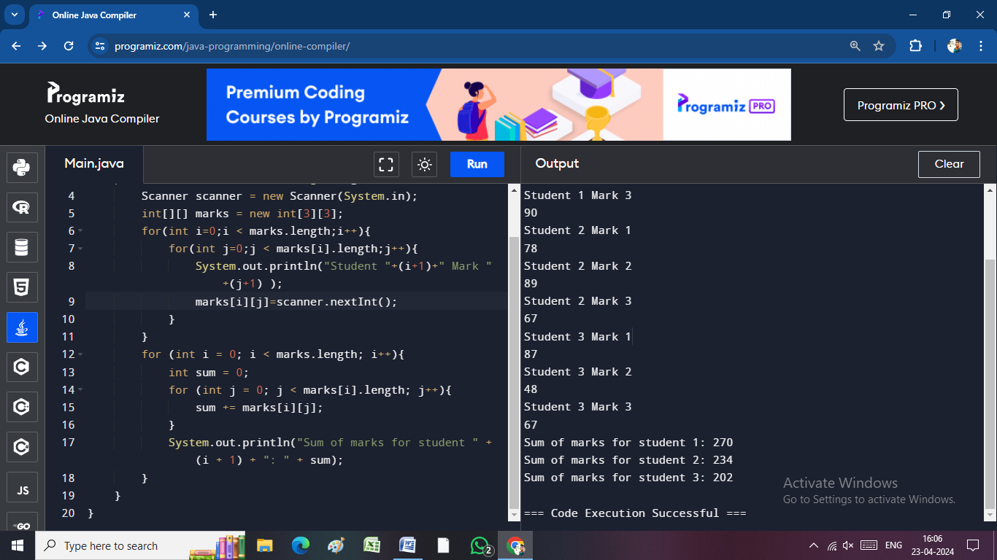public class Array2d {

public static void main(String[] args) {

Scanner scanner = new Scanner(System.in);

int[][] marks = new int[3][3];

for(int i=0;i < marks.length;i++){

for(int j=0;j < marks[i].length;j++){

System.out.println("Student "+(i+1)+" Mark "+(j+1) );

marks[i][j]=scanner.nextInt();

}

}

for (int i = 0; i < marks.length; i++){

int sum = 0;

for (int j = 0; j < marks[i].length; j++){

sum += marks[i][j];

avg=marks[i][j]/3;

}

System.out.println("Sum of marks for student " + (i + 1) + ": " + sum);

System.out.println("Sum of marks for student " + (i + 1) + ": " + avg);

}

}

}

import java.util.Scanner;

public class Array2d {

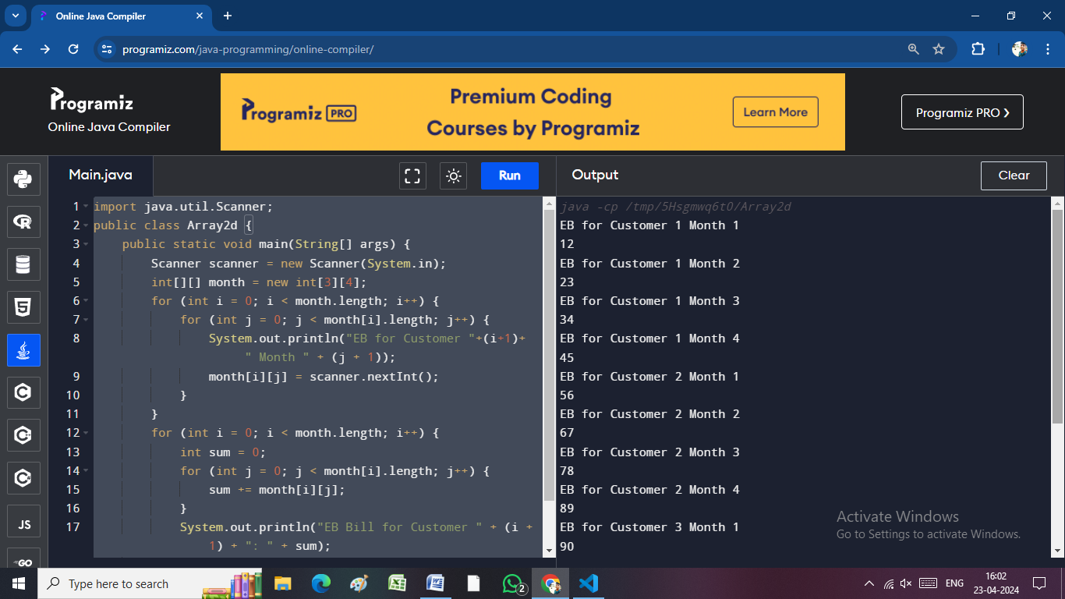 public static void main(String[] args) {

Scanner scanner = new Scanner(System.in);

int[][] month = new int[3][4];

for (int i = 0; i < month.length; i++) {

for (int j = 0; j < month[i].length; j++) {

System.out.println("EB for Customer "+(i+1)+ " Month " + (j + 1));

month[i][j] = scanner.nextInt();

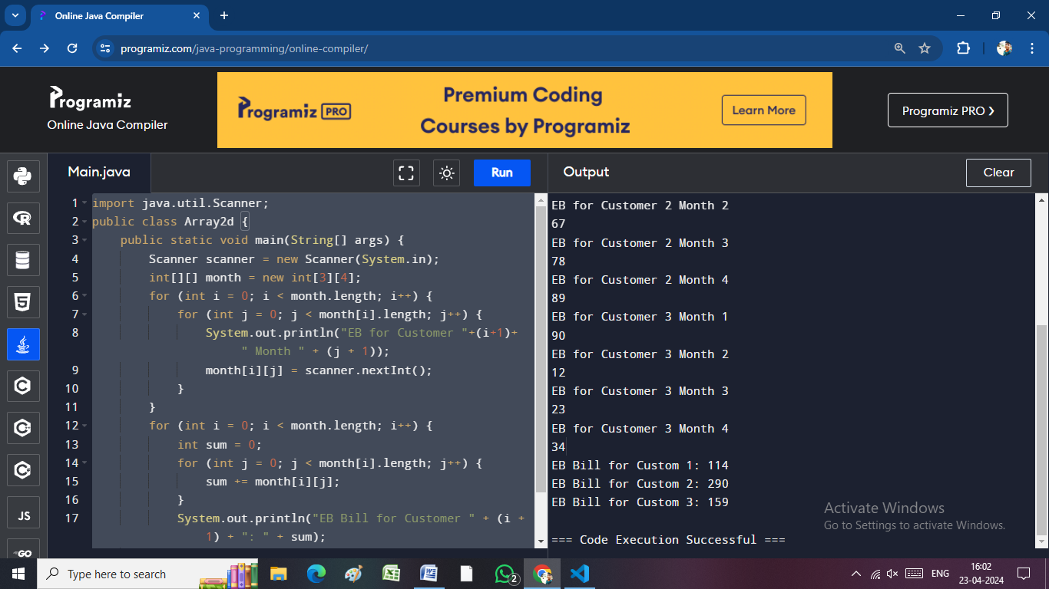 }

}

for (int i = 0; i < month.length; i++) {

int sum = 0;

for (int j = 0; j < month[i].length; j++) {

sum += month[i][j];

}

System.out.println("EB Bill for Customer " + (i + 1) + ": " + sum);

}

}

}

**FUNCTION:**

import java.io.BufferedReader;

import java.io.IOException;

import java.io.InputStreamReader;

public class Functions_in_java {

static BufferedReader input = new BufferedReader(new InputStreamReader(System.in));

public static void addition() throws IOException {

System.out.println("Add Function called");

System.out.println("Enter the value for A:");

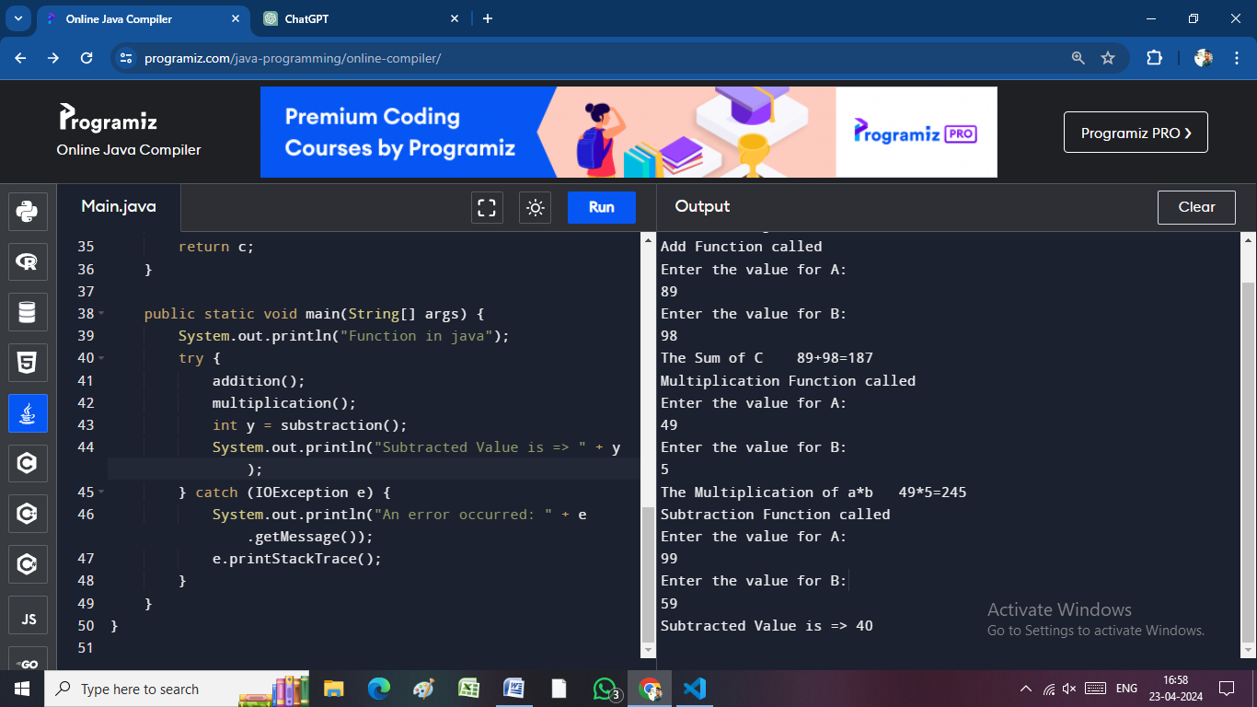 int a = Integer.parseInt(input.readLine());

System.out.println("Enter the value for B:");

int b = Integer.parseInt(input.readLine());

int c = a + b;

System.out.println("The Sum of C\t" + a + "+" + b + "=" + c);

}

public static void multiplication() throws IOException {

System.out.println("Multiplication Function called");

System.out.println("Enter the value for A:");

int a = Integer.parseInt(input.readLine());

System.out.println("Enter the value for B:");

int b = Integer.parseInt(input.readLine());

int c = a * b;

System.out.println("The Multiplication of a*b\t" + a + "*" + b + "=" + c);

}

public static int substraction() throws IOException {

System.out.println("Subtraction Function called");

System.out.println("Enter the value for A:");

int a = Integer.parseInt(input.readLine());

System.out.println("Enter the value for B:");

int b = Integer.parseInt(input.readLine());

int c = a - b;

return c;

}

public static void main(String[] args) {

System.out.println("Function in java");

try {

addition();

multiplication();

int y = substraction();

System.out.println("Subtracted Value is => " + y);

} catch (IOException e) {

System.out.println("An error occurred: " + e.getMessage());

e.printStackTrace();

}

}

}

import java.io.*;

public class Switch{

public static void main(String[] args) throws IOException {

int[] a = new int [10];

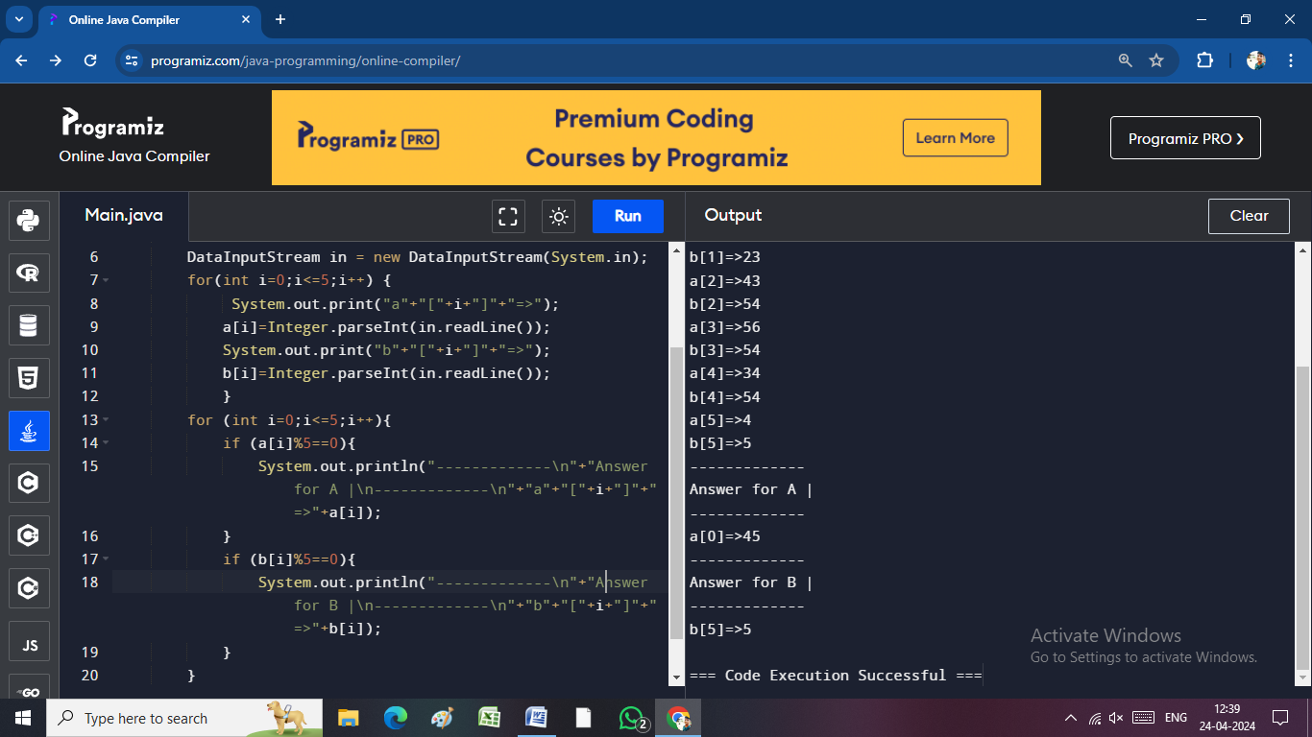 int[] b = new int [10];

DataInputStream in = new DataInputStream(System.in);

for(int i=0;i<=5;i++) {

System.out.print("a"+"["+i+"]"+"=>");

a[i]=Integer.parseInt(in.readLine());

System.out.print("b"+"["+i+"]"+"=>");

b[i]=Integer.parseInt(in.readLine());

}

for (int i=0;i<=5;i++){

if (a[i]%5==0){

System.out.println("-------------\n"+"Answer for A |\n-------------\n"+"a"+"["+i+"]"+"=>"+a[i]);

}

if (b[i]%5==0){

System.out.println("-------------\n"+"Answer for B |\n-------------\n"+"b"+"["+i+"]"+"=>"+b[i]);

}

}

}

**ARRAY ADDITION :**

import java.io.*;

public class SwitchCase {

public static void main(String[] args) throws IOException {

int[][] a = new int[2][2];

int[][] b = new int[2][2];

int[][] c = new int[2][2];

BufferedReader in = new BufferedReader(new InputStreamReader(System.in));

for (int i = 0; i < 2; i++) {

System.out.println("Enter A Array " + i + " Values => ");

for (int j = 0; j < 2; j++) {

a[i][j] = Integer.parseInt(in.readLine());

}

System.out.println("Enter B Array " + i + " Values => ");

for (int j = 0; j < 2; j++) {

b[i][j] = Integer.parseInt(in.readLine());

}

}

for (int i = 0; i < 2; i++) {

for (int j = 0; j < 2; j++) {

c[i][j] = a[i][j] + b[i][j];

}

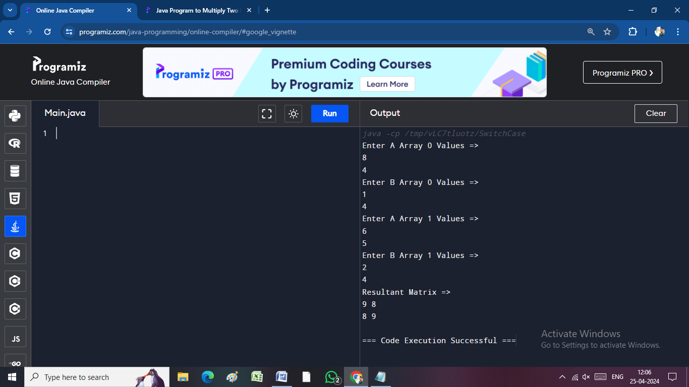 }

System.out.println("Resultant Matrix =>");

for (int i = 0; i < 2; i++) {

for (int j = 0; j < 2; j++) {

System.out.print(c[i][j]+ " ");

}

System.out.println("");

}

}

}

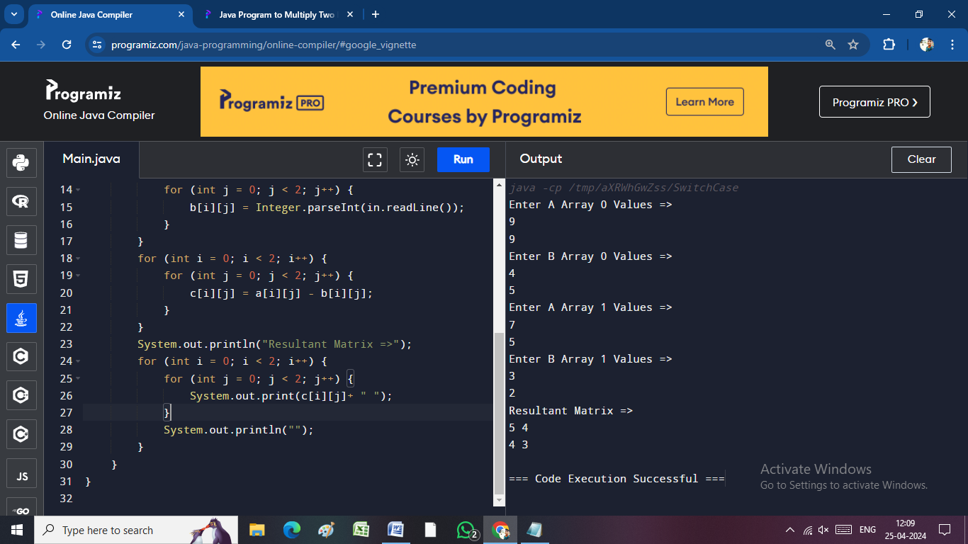**ARRAY SUBRACTION :**

import java.io.*;

public class SwitchCase {

public static void main(String[] args) throws IOException {

int[][] a = new int[2][2];

int[][] b = new int[2][2];

int[][] c = new int[2][2];

BufferedReader in = new BufferedReader(new InputStreamReader(System.in));

for (int i = 0; i < 2; i++) {

System.out.println("Enter A Array " + i + " Values => ");

for (int j = 0; j < 2; j++) {

a[i][j] = Integer.parseInt(in.readLine());

}

System.out.println("Enter B Array " + i + " Values => ");

for (int j = 0; j < 2; j++) {

b[i][j] = Integer.parseInt(in.readLine());

}

}

for (int i = 0; i < 2; i++) {

for (int j = 0; j < 2; j++) {

c[i][j] = a[i][j] - b[i][j];

}

}

System.out.println("Resultant Matrix =>");

for (int i = 0; i < 2; i++) {

for (int j = 0; j < 2; j++) {

System.out.print(c[i][j]+ " ");

}

System.out.println("");

}

}

}

**ARRAY MULTILPICATION :**

import java.io.*;

public class SwitchCase {

public static void main(String[] args) throws IOException {

int[][] a = new int[2][2];

int[][] b = new int[2][2];

int[][] c = new int[2][2];

BufferedReader in = new BufferedReader ( **n**ew **I**nput**S**tream**R**eader(System.in));

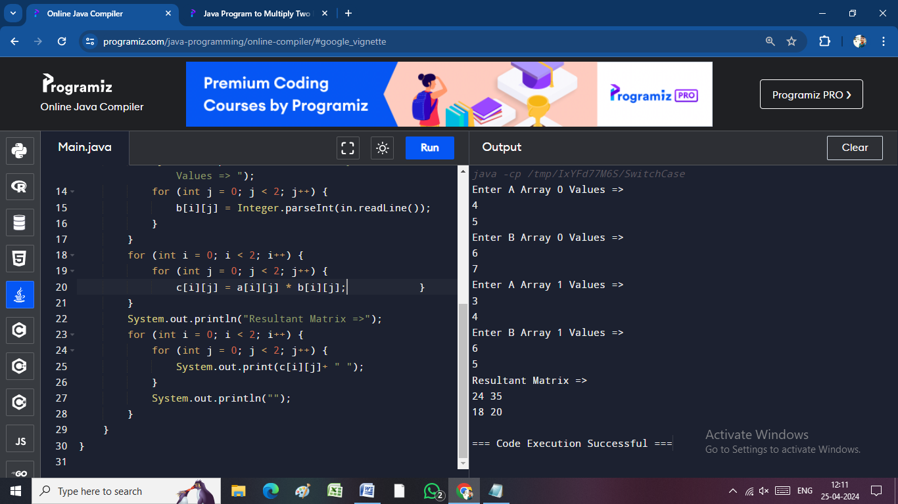 for (int i = 0; i < 2; i++) {

System.out.println("Enter A Array " + i + " Values => ");

for (int j = 0; j < 2; j++) {

a[i][j] = Integer.parseInt(in.readLine());

}

System.out.println("Enter B Array " + i + " Values => ");

for (int j = 0; j < 2; j++) {

b[i][j] = Integer.parseInt(in.readLine());

}

}

for (int i = 0; i < 2; i++) {

for (int j = 0; j < 2; j++) {

c[i][j] = a[i][j] * b[i][j];

}

}

System.out.println("Resultant Matrix =>");

for (int i = 0; i < 2; i++) {

for (int j = 0; j < 2; j++) {

System.out.print(c[i][j]+ " ");

}

System.out.println("");

}

}

}

import java.io.*;

public class SwitchCase {

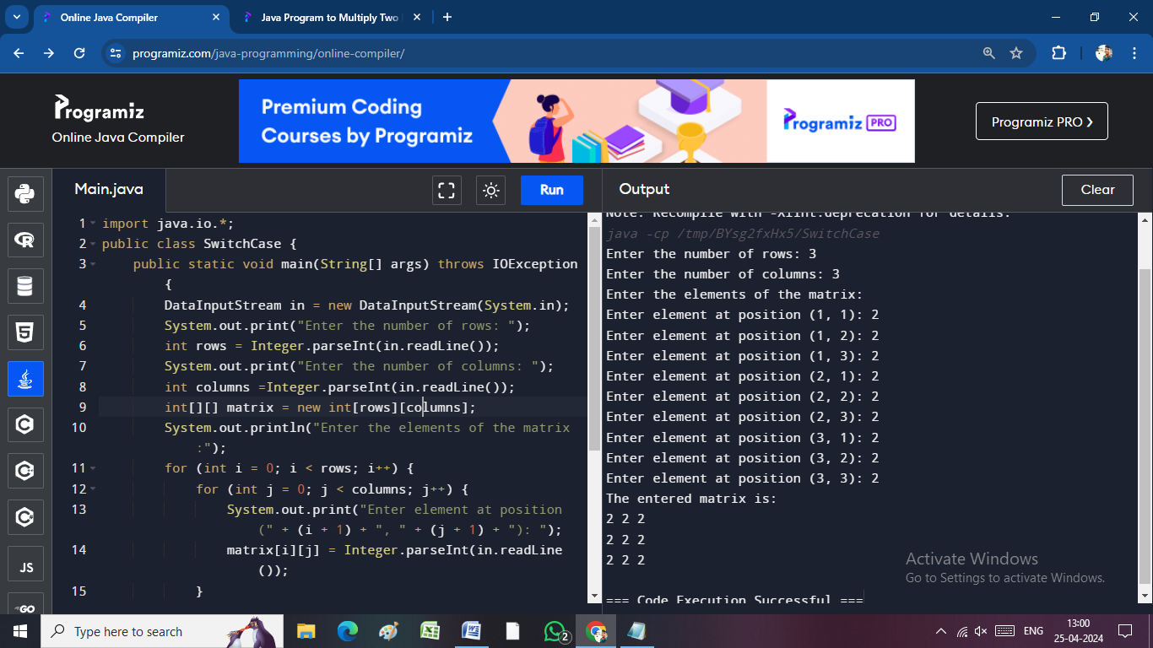 public static void main(String[] args) throws IOException {

DataInputStream in = new DataInputStream(System.in);

For(int i=0;i<=2;i++){

System.out.print("Enter the number of rows: ");

int rows = Integer.parseInt(in.readLine());

System.out.print("Enter the number of columns: ");

int columns =Integer.parseInt(in.readLine());

int[][] matrix = new int[rows][columns];

System.out.println("Enter the elements of the matrix:");

}for (int i = 0; i < rows; i++) {

for (int j = 0; j < columns; j++) {

System.out.print("Enter element at position (" + (i + 1) + ", " + (j + 1) + "): ");

matrix[i][j] = Integer.parseInt(in.readLine());

}

}

System.out.println("The entered matrix is:");

for (int i = 0; i < rows; i++) {

for (int j = 0; j < columns; j++) {

System.out.print(matrix[i][j] + " ");

}

System.out.println();

}

}

}

**ADDING TWO MATRICES :**

import java.io.*;

public class Case {

public static void main(String[] args) throws IOException {

DataInputStream in = new DataInputStream(System.in);

System.out.println("Enter details for the first matrix:");

System.out.print("Enter the number of rows: ");

int rows1 = Integer.parseInt(in.readLine());

System.out.print("Enter the number of columns: ");

int columns1 = Integer.parseInt(in.readLine());

int[][] matrix1 = new int[rows1][columns1];

System.out.println("Enter the elements of the first matrix:");

for (int i = 0; i < rows1; i++) {

for (int j = 0; j < columns1; j++) {

System.out.print("Enter element at position (" + (i + 1) + ", " + (j + 1) + "): ");

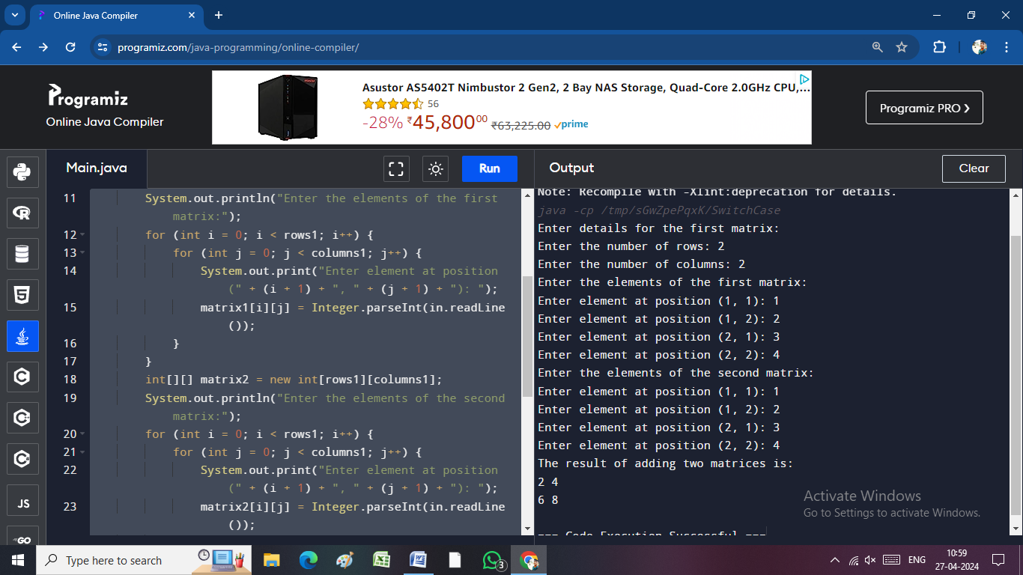 matrix1[i][j] = Integer.parseInt(in.readLine());

}

}

int[][] matrix2 = new int[rows1][columns1];

System.out.println("Enter the elements of the second matrix:");

for (int i = 0; i < rows1; i++) {

for (int j = 0; j < columns1; j++) {

System.out.print("Enter element at position (" + (i + 1) + ", " + (j + 1) + "): ");

matrix2[i][j] = Integer.parseInt(in.readLine());

}

}

int[][] resultMatrix = new int[rows1][columns1];

for (int i = 0; i < rows1; i++) {

for (int j = 0; j < columns1; j++) {

resultMatrix[i][j] = matrix1[i][j] + matrix2[i][j];

}

}

System.out.println("The result of adding two matrices is:");

for (int i = 0; i < rows1; i++) {

for (int j = 0; j < columns1; j++) {

System.out.print(resultMatrix[i][j] + " ");

}

System.out.println();

}

}

}

**SUBRACTING TWO MATRICES :**

import java.io.*;

public class SwitchCase {

public static void main(String[] args) throws IOException {

DataInputStream in = new DataInputStream(System.in);

System.out.println("Enter details for the first matrix:");

System.out.print("Enter the number of rows: ");

int rows1 = Integer.parseInt(in.readLine());

System.out.print("Enter the number of columns: ");

int columns1 = Integer.parseInt(in.readLine());

int[][] matrix1 = new int[rows1][columns1];

System.out.println("Enter the elements of the first matrix:");

for (int i = 0; i < rows1; i++) {

for (int j = 0; j < columns1; j++) {

System.out.print("Enter element at position (" + (i + 1) + ", " + (j + 1) + "): ");

matrix1[i][j] = Integer.parseInt(in.readLine());

}

}

int[][] matrix2 = new int[rows1][columns1];

System.out.println("Enter the elements of the second matrix:");

for (int i = 0; i < rows1; i++) {

for (int j = 0; j < columns1; j++) {

System.out.print("Enter element at position (" + (i + 1) + ", " + (j + 1) + "): ");

matrix2[i][j] = Integer.parseInt(in.readLine());

}

}

int[][] resultMatrix = new int[rows1][columns1];

for (int i = 0; i < rows1; i++) {

for (int j = 0; j < columns1; j++) {

resultMatrix[i][j] = matrix1[i][j] - matrix2[i][j];

}

}

System.out.println("The result of subracting two matrices is:");

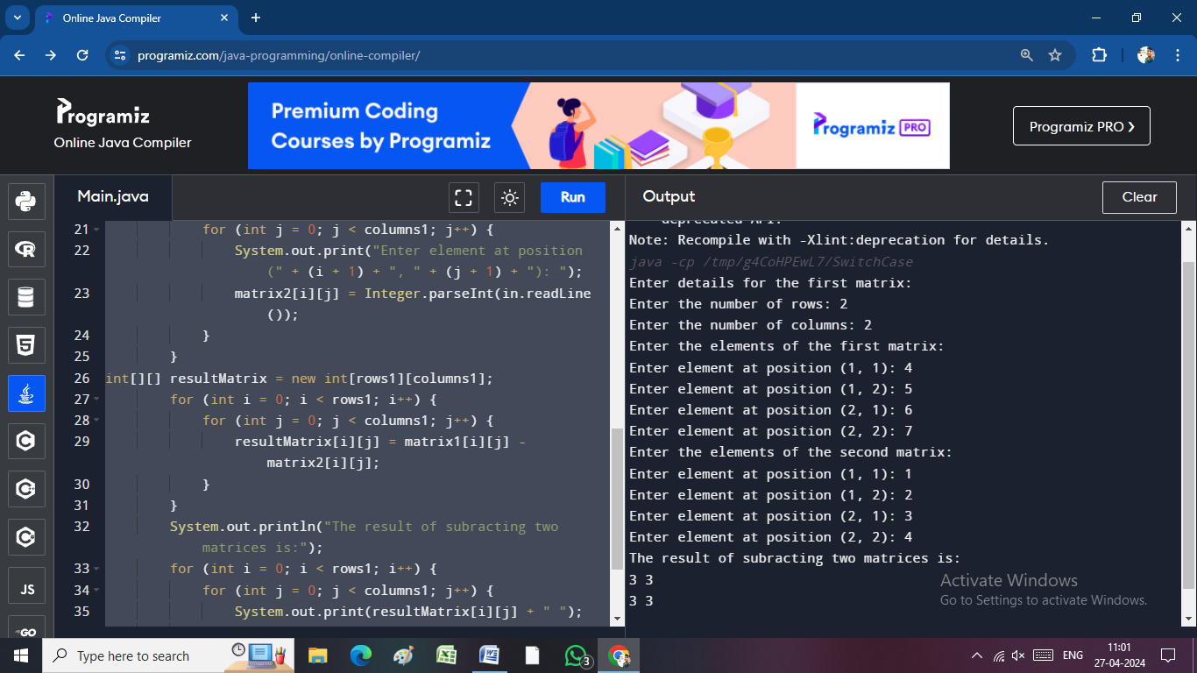 for (int i = 0; i < rows1; i++) {

for (int j = 0; j < columns1; j++) {

System.out.print(resultMatrix[i][j] + " ");

}

System.out.println();

}

}

}

**Multiplying Two Matrices :**

import java.io.*;

public class SwitchCase {

public static void main(String[] args) throws IOException {

DataInputStream in = new DataInputStream(System.in);

System.out.println("Enter details for the first matrix:");

System.out.print("Enter the number of rows: ");

int rows1 = Integer.parseInt(in.readLine());

System.out.print("Enter the number of columns: ");

int columns1 = Integer.parseInt(in.readLine());

int[][] matrix1 = new int[rows1][columns1];

System.out.println("Enter the elements of the first matrix:");

for (int i = 0; i < rows1; i++) {

for (int j = 0; j < columns1; j++) {

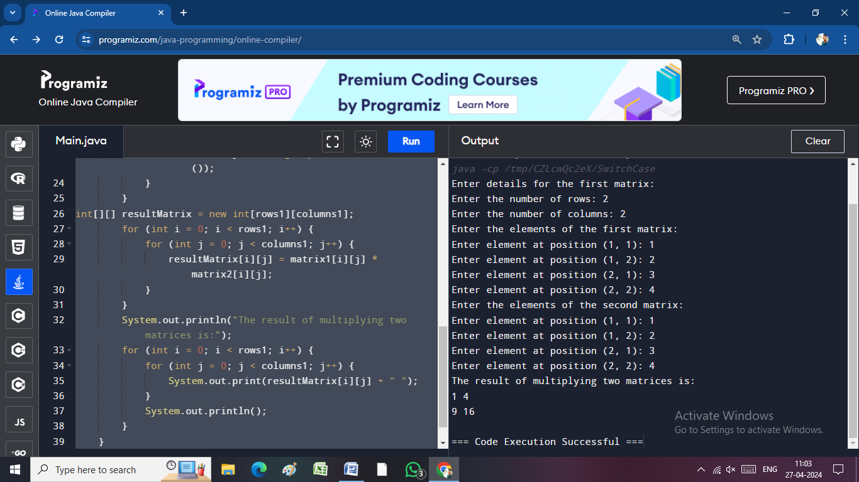 System.out.print("Enter element at position (" + (i + 1) + ", " + (j + 1) + "): ");

matrix1[i][j] = Integer.parseInt(in.readLine());

}

}

int[][] matrix2 = new int[rows1][columns1];

System.out.println("Enter the elements of the second matrix:");

for (int i = 0; i < rows1; i++) {

for (int j = 0; j < columns1; j++) {

System.out.print("Enter element at position (" + (i + 1) + ", " + (j + 1) + "): ");

matrix2[i][j] = Integer.parseInt(in.readLine());

}

}

int[][] resultMatrix = new int[rows1][columns1];

for (int i = 0; i < rows1; i++) {

for (int j = 0; j < columns1; j++) {

resultMatrix[i][j] = matrix1[i][j] * matrix2[i][j];

}

}

System.out.println("The result of multiplying two matrices is:");

for (int i = 0; i < rows1; i++) {

for (int j = 0; j < columns1; j++) {

System.out.print(resultMatrix[i][j] + " ");

}

System.out.println();

}

}

}

**Student Rank List :**

import java.util.Scanner;

public class Array2d {

public static void main(String[] args) {

Scanner scanner = new Scanner(System.in);

int[][] marks = new int[3][3];

float avg = 0;

int[] totals = new int[3];

for (int i = 0; i < marks.length; i++) {

for (int j = 0; j < marks[i].length; j++) {

System.out.println("Student " + (i + 1) + " Mark " + (j + 1));

marks[i][j] = scanner.nextInt();

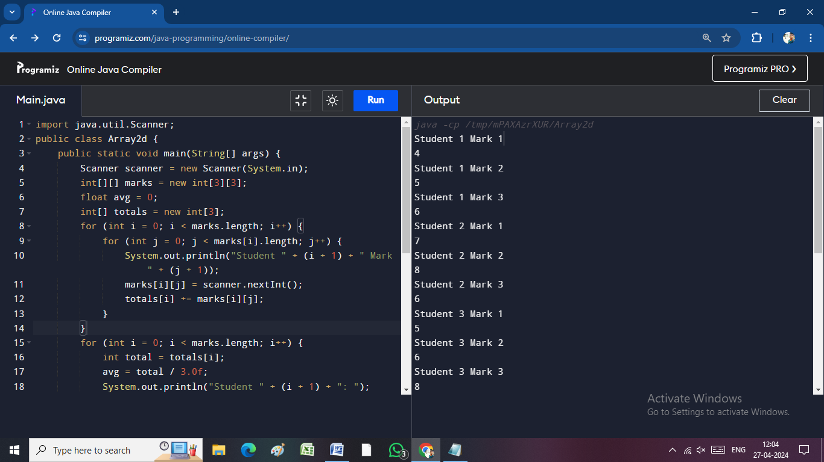 totals[i] += marks[i][j];

}

}

for (int i = 0; i < marks.length; i++) {

int total = totals[i];

avg = total / 3.0f;

System.out.println("Student " + (i + 1) + ": ");

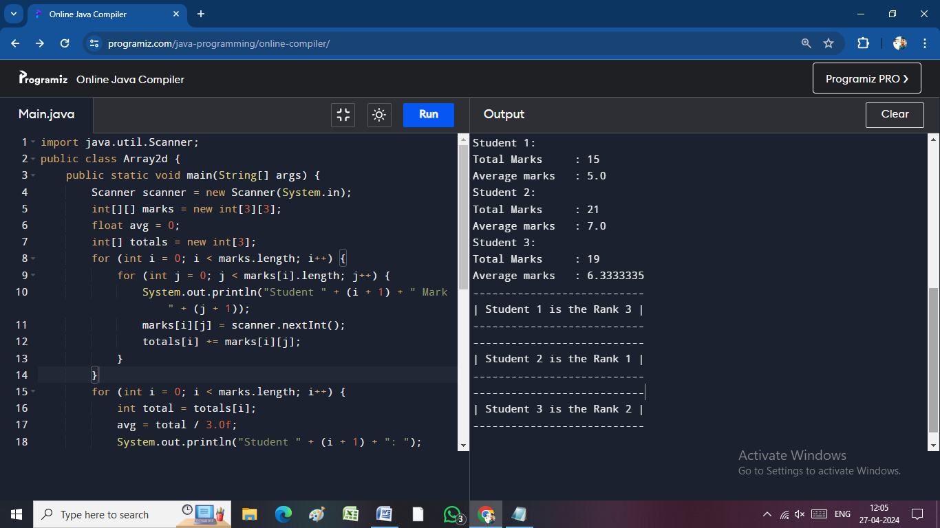 System.out.println("Total Marks \t: " + total);

System.out.println("Average marks \t: " + avg);

}

int[] ranks = new int[3];

for (int i = 0; i < ranks.length; i++) {

ranks[i] = 1;

for (int j = 0; j < ranks.length; j++) {

if (totals[j] > totals[i]) {

ranks[i]++; }

}

}

for (int i = 0; i < ranks.length; i++) {

System.out.println("---------------------------\n| Student "+(i+1)+" is the "+"Rank "+ranks[i]+" |\n---------------------------");

}

}

}

**JAVA STRING :(change character by index value)(Substring)**

import java.io.*;

public class SwitchCase {

public static void main(String[] args) throws IOException {

DataInputStream in = new DataInputStream(System.in);

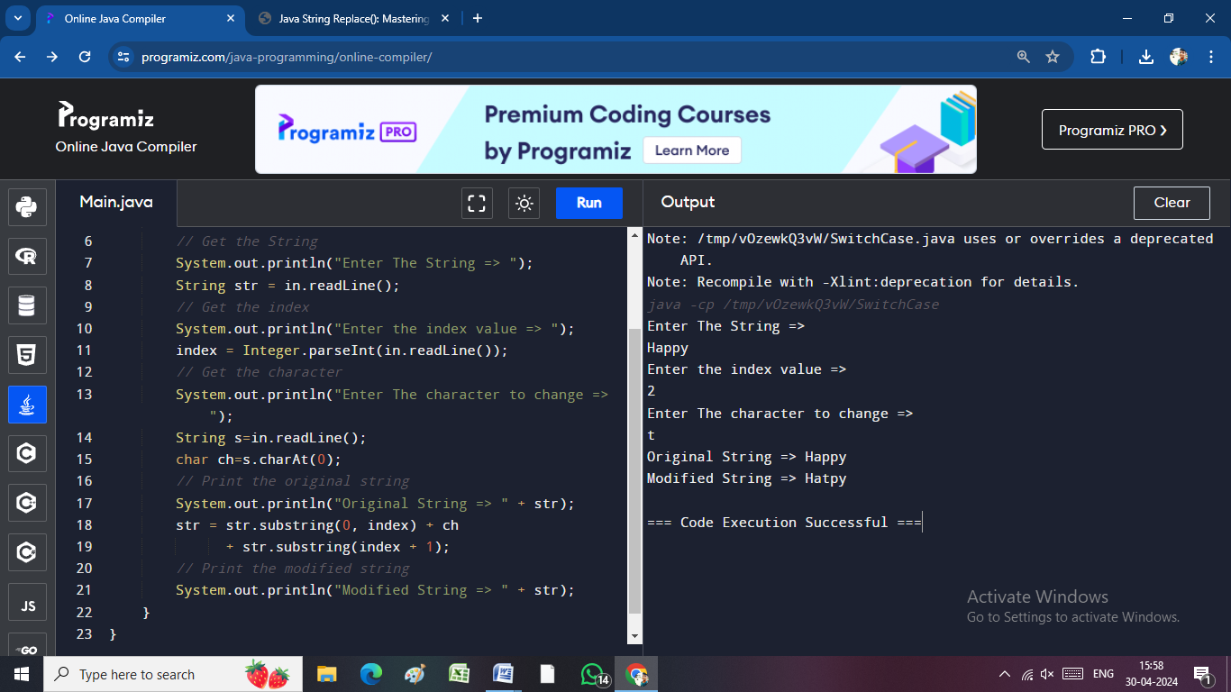 int index=0;

// Get the String

System.out.println("Enter The String => ");

String str = in.readLine();

// Get the index

System.out.println("Enter the index value => ");

index = Integer.parseInt(in.readLine());

// Get the character

System.out.println("Enter The character to change => ");

String s=in.readLine();

char ch=s.charAt(0);

// Print the original string

System.out.println("Original String => " + str);

str = str.substring(0, index) + ch

+ str.substring(index + 1);

// Print the modified string

System.out.println("Modified String => " + str);

}

}

**Character change :(Replace)**

import java.io.*;

public class SwitchCase {

public static void main(String[] args) throws IOException {

BufferedReader in = new BufferedReader(new InputStreamReader(System.in));

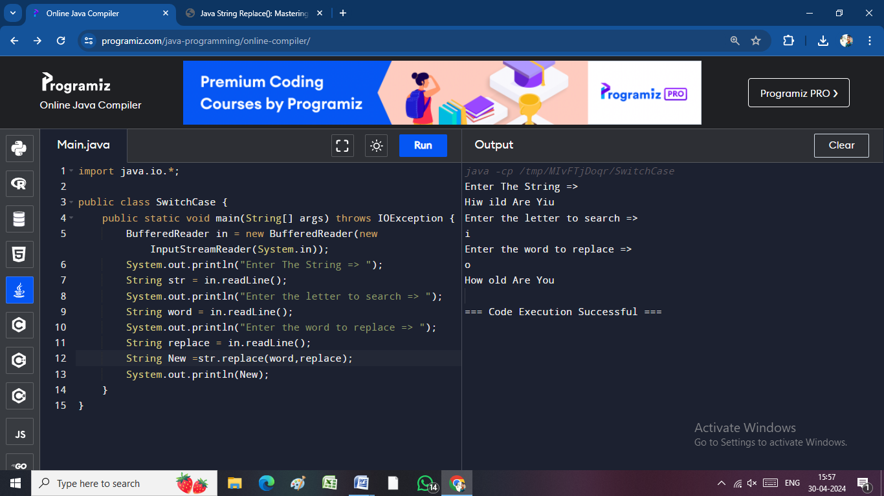 System.out.println("Enter The String => ");

String str = in.readLine();

System.out.println("Enter the letter to search => ");

String word = in.readLine();

System.out.println("Enter the word to replace => ");

String replace = in.readLine();

String New =str.replace(word,replace);

System.out.println(New);

}

}

**STRING (**[**char charAt()**](https://www.javatpoint.com/java-string-charat)**):**

import java.io.*;

public class SwitchCase {

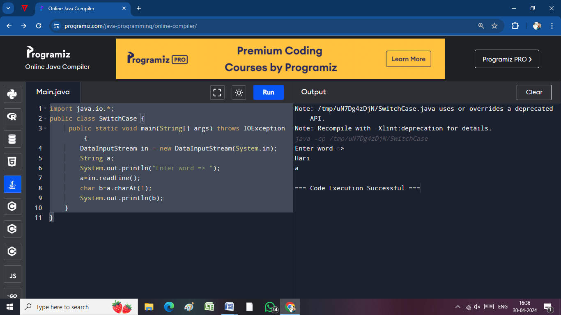 public static void main(String[] args) throws IOException {

DataInputStream in = new DataInputStream(System.in);

String a;

System.out.println("Enter word => ");

a=in.readLine();

char b=a.charAt(1);

System.out.println(b);

}

}

[**int length()**](https://www.javatpoint.com/java-string-length)**:**

import java.io.*;

public class SwitchCase {

public static void main(String[] args) throws IOException {

DataInputStream in = new DataInputStream(System.in);

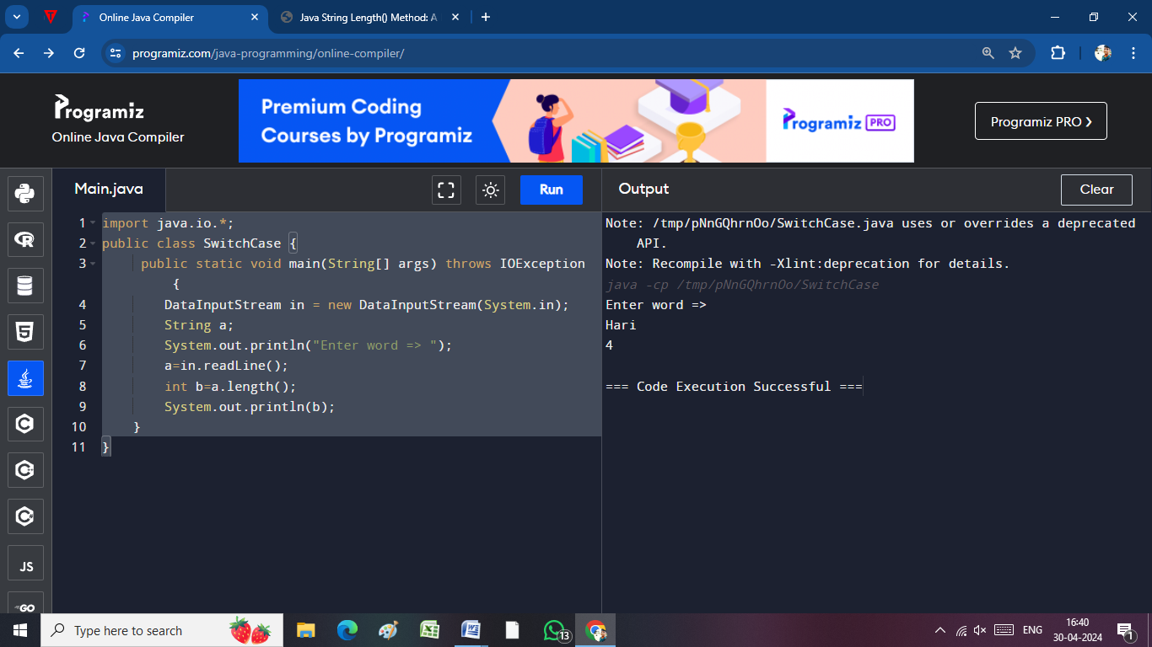 String a;

System.out.println("Enter word => ");

a=in.readLine();

int b=a.length();

System.out.println(b);

}

}

[**boolean contains(CharSequence s)**](https://www.javatpoint.com/java-string-contains)**:**

import java.io.*;

public class Case {

public static void main(String[] args) throws IOException {

BufferedReader reader = new BufferedReader(new InputStreamReader(System.in));

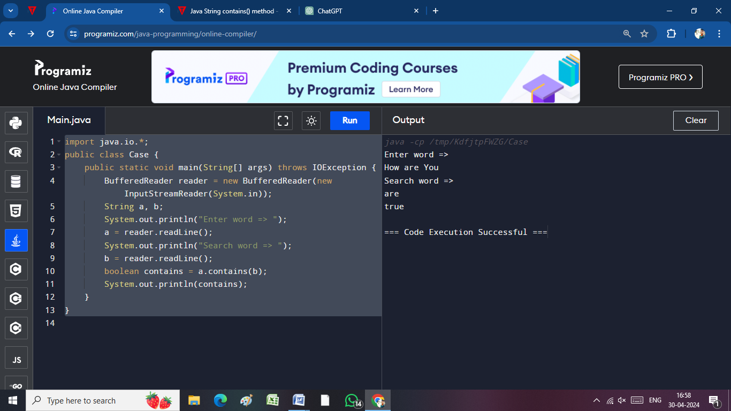 String a, b;

System.out.println("Enter word => ");

a = reader.readLine();

System.out.println("Search word => ");

b = reader.readLine();

boolean contains = a.contains(b);

System.out.println(contains);

}

}

[**boolean equals(Object another)**](https://www.javatpoint.com/java-string-equals)**:**

import java.io.*;

public class Case {

public static void main(String[] args) throws IOException {

BufferedReader reader = new BufferedReader(new InputStreamReader(System.in));

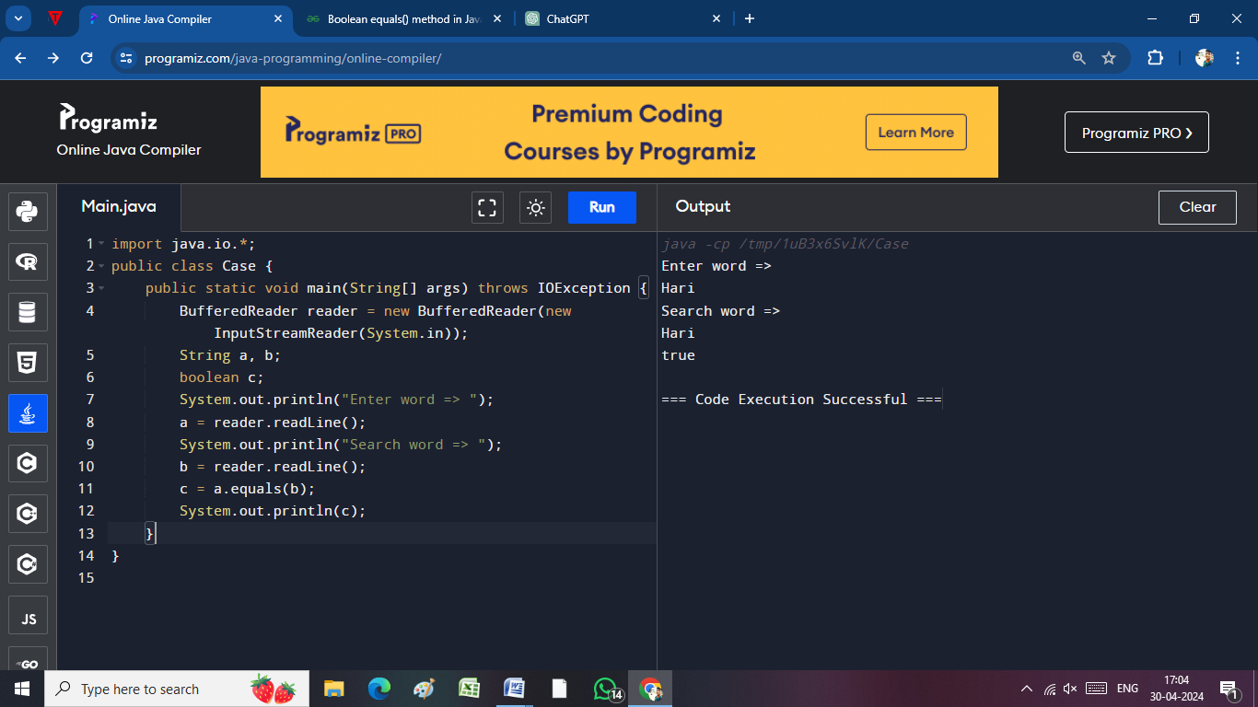 String a, b;

boolean c;

System.out.println("Enter word => ");

a = reader.readLine();

System.out.println("Search word => ");

b = reader.readLine();

c = a.equals(b);

System.out.println(c);

}

}

[**boolean isEmpty()**](https://www.javatpoint.com/java-string-isempty)

//if empty it show true

import java.io.*;

public class Case {

public static void main(String[] args) throws IOException {

BufferedReader reader = new BufferedReader(new InputStreamReader(System.in));

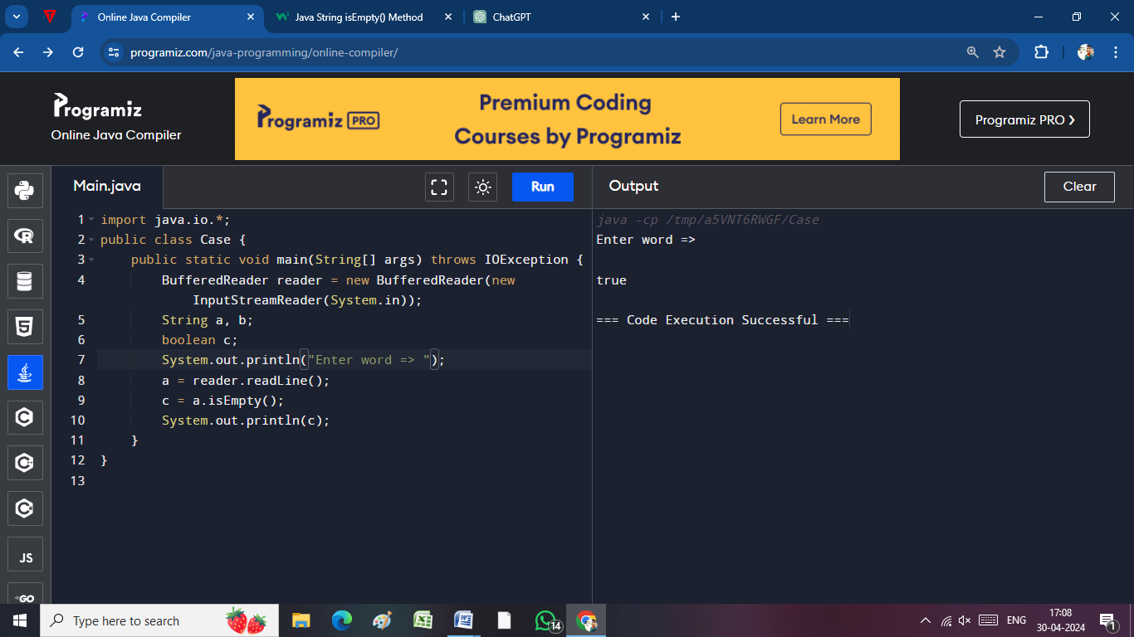 String a, b;

boolean c;

System.out.println("Enter word => ");

a = reader.readLine();

c = a.isEmpty();

System.out.println(c);

}

}

[**String concat(String str)**](https://www.javatpoint.com/java-string-concat)**:**

import java.io.*;

public class Case {

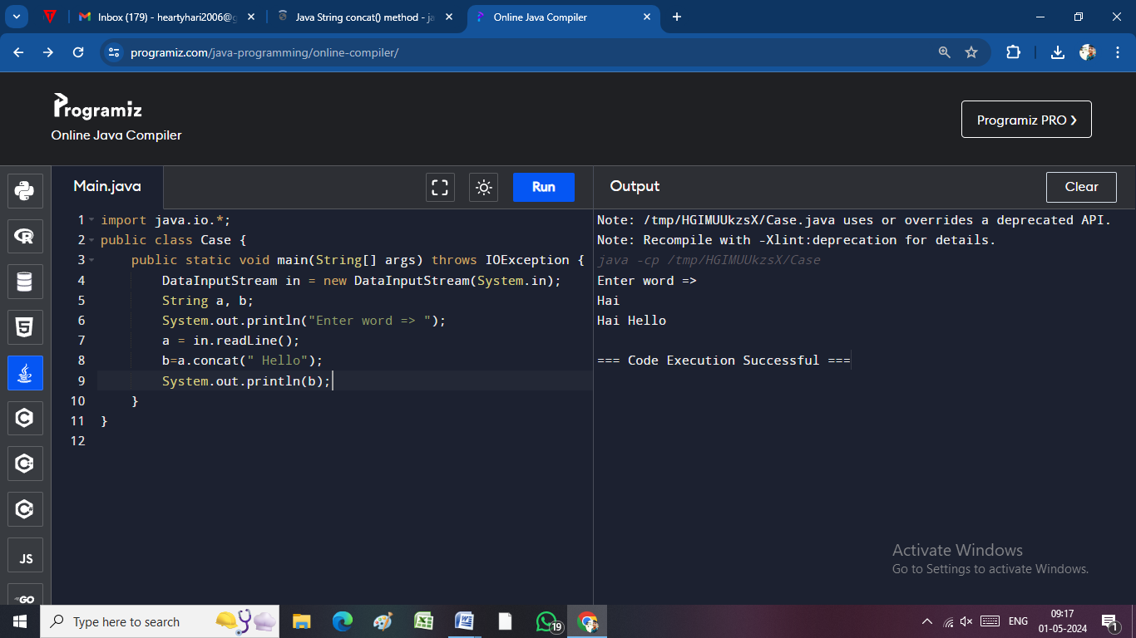 public static void main(String[] args) throws IOException {

DataInputStream in = new DataInputStream(System.in);

String a, b;

System.out.println("Enter word => ");

a = in.readLine();

b=a.concat(" Hello");

System.out.println(b);

}

}

[**static String equalsIgnoreCase(String another)**](https://www.javatpoint.com/java-string-equalsignorecase)**:**

import java.io.*;

public class Case {

public static void main(String[] args) throws IOException {

DataInputStream in = new DataInputStream(System.in);

String a, b;

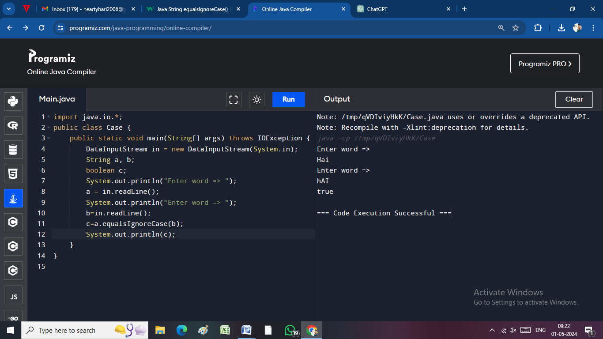 boolean c;

System.out.println("Enter word => ");

a = in.readLine();

System.out.println("Enter word => ");

b=in.readLine();

c=a.equalsIgnoreCase(b);

System.out.println(c);

}

}

[**String[] split(String regex)**](https://www.javatpoint.com/java-string-split)**:**

[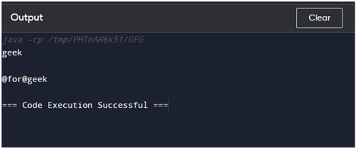](https://www.blogger.com/blog/post/edit/9203030504722323244/8846374258555900708)public class GFG {

    public static void main(String args [ ] )

    {

        String str = "geekss@for@geekss";

        String[] arrOfStr = str.split("s", 0);

        for (String a : arrOfStr)

            System.out.println(a);

    }

}

[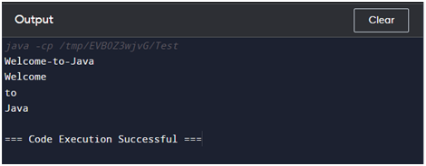](https://www.blogger.com/blog/post/edit/9203030504722323244/8846374258555900708)[**String[] split(String regex, int limit)**](https://www.javatpoint.com/java-string-split)**:**

import java.io.*;

public class Test {

   public static void main(String args[]) {

      String Str = new String("Welcome-to-Java");

      System.out.println(Str);

      for (String retval: Str.split("-",10 )) {

         System.out.println(retval);

      }

   }

}

[**String intern()**](https://www.javatpoint.com/java-string-intern)**:**

import java.io.*;

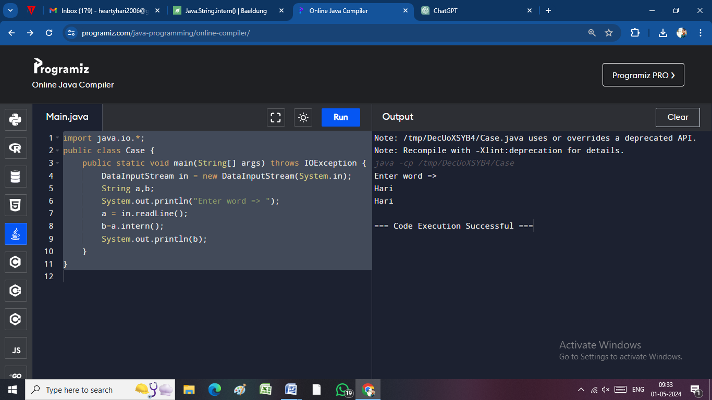public class Case {

public static void main(String[] args) throws IOException {

DataInputStream in = new DataInputStream(System.in);

String a,b;

System.out.println("Enter word => ");

a = in.readLine();

b=a.intern();

System.out.println(b);

}

}

[**int indexOf(int ch)**](https://www.javatpoint.com/java-string-indexof)**:**

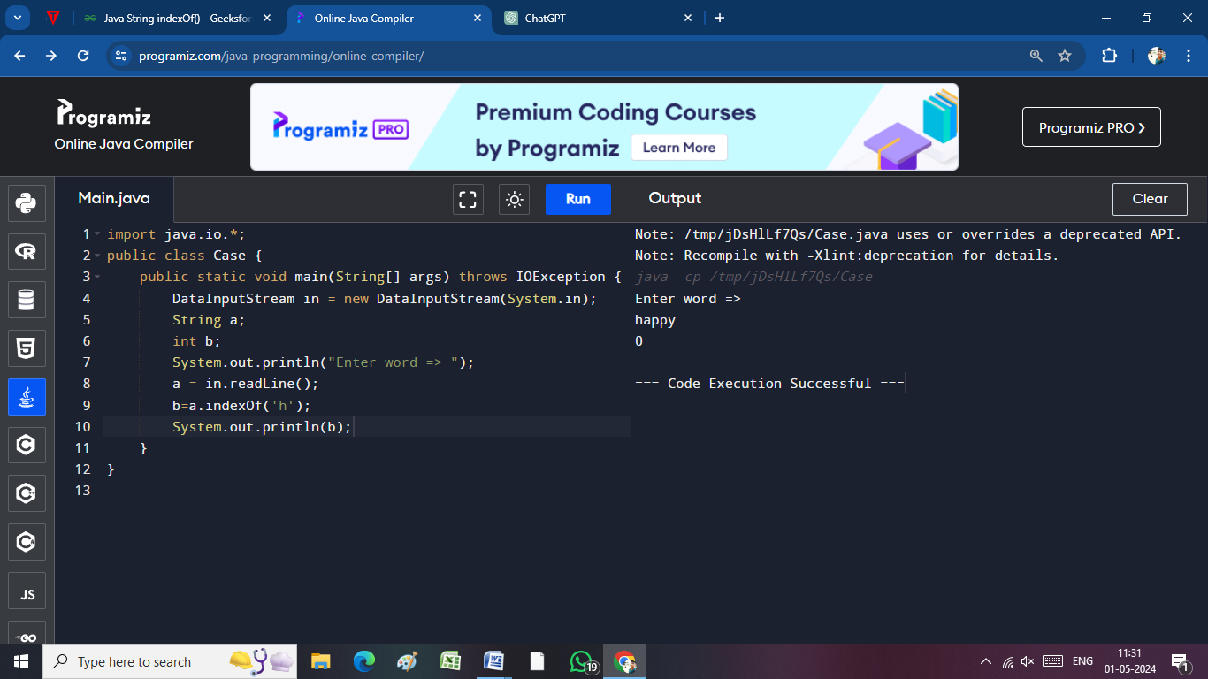import java.io.*;

public class Case {

public static void main(String[] args) throws IOException {

DataInputStream in = new DataInputStream(System.in);

String a;

int b;

System.out.println("Enter word => ");

a = in.readLine();

b=a.indexOf('h');

System.out.println(b);

}

}

[**int indexOf(int ch, int fromIndex)**](https://www.javatpoint.com/java-string-indexof)**:**

import java.io.*;

public class Case {

public static void main(String[] args) throws IOException {

DataInputStream in = new DataInputStream(System.in);

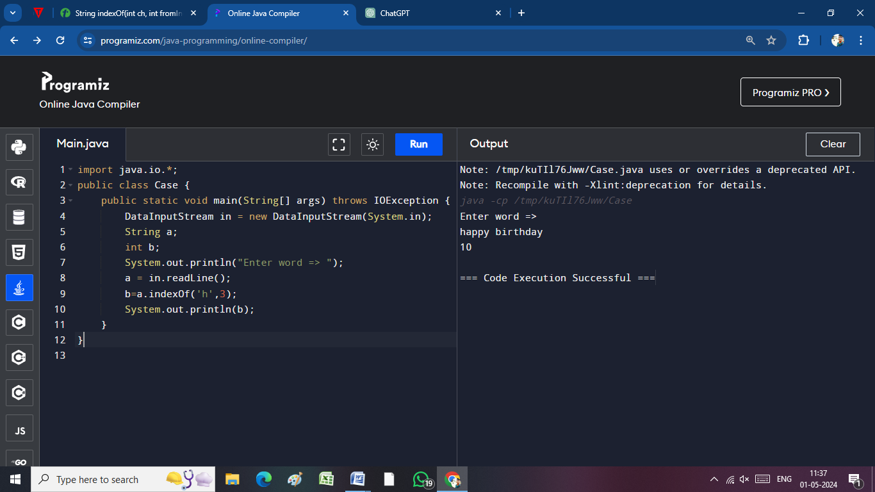 String a;

int b;

System.out.println("Enter word => ");

a = in.readLine();

b=a.indexOf('h',3);

System.out.println(b);

}

}

[**int indexOf(String substring)**](https://www.javatpoint.com/java-string-indexof)**:**

import java.io.*;

public class Case {

public static void main(String[] args) throws IOException {

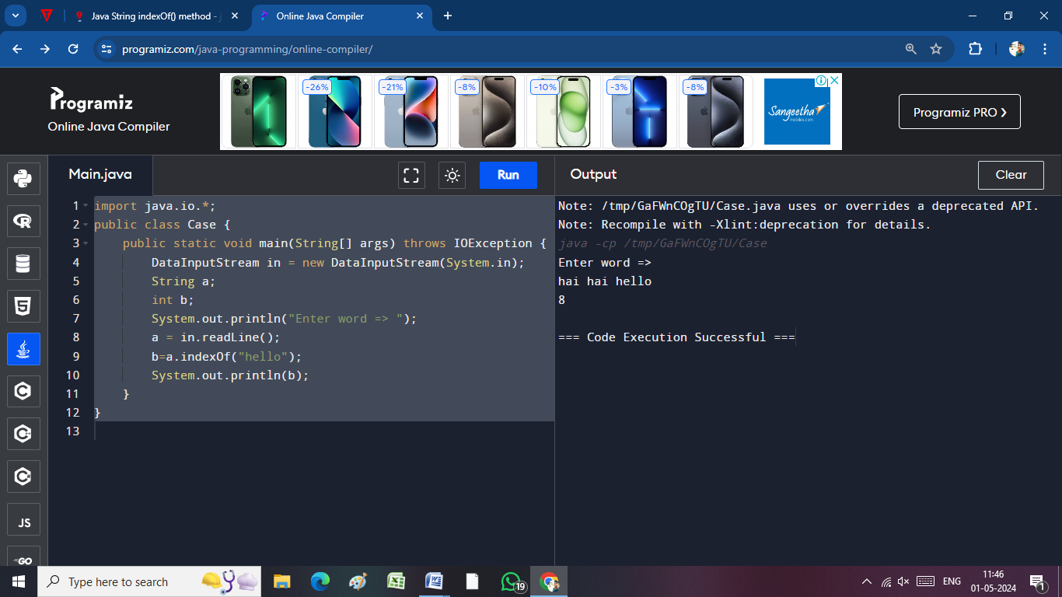 DataInputStream in = new DataInputStream(System.in);

String a;

int b;

System.out.println("Enter word => ");

a = in.readLine();

b=a.indexOf("hello");

System.out.println(b);

}

}

[**int indexOf(String substring, int fromIndex)**](https://www.javatpoint.com/java-string-indexof)**:**

import java.io.*;

public class Case {

public static void main(String[] args) throws IOException {

DataInputStream in = new DataInputStream(System.in);

String a;

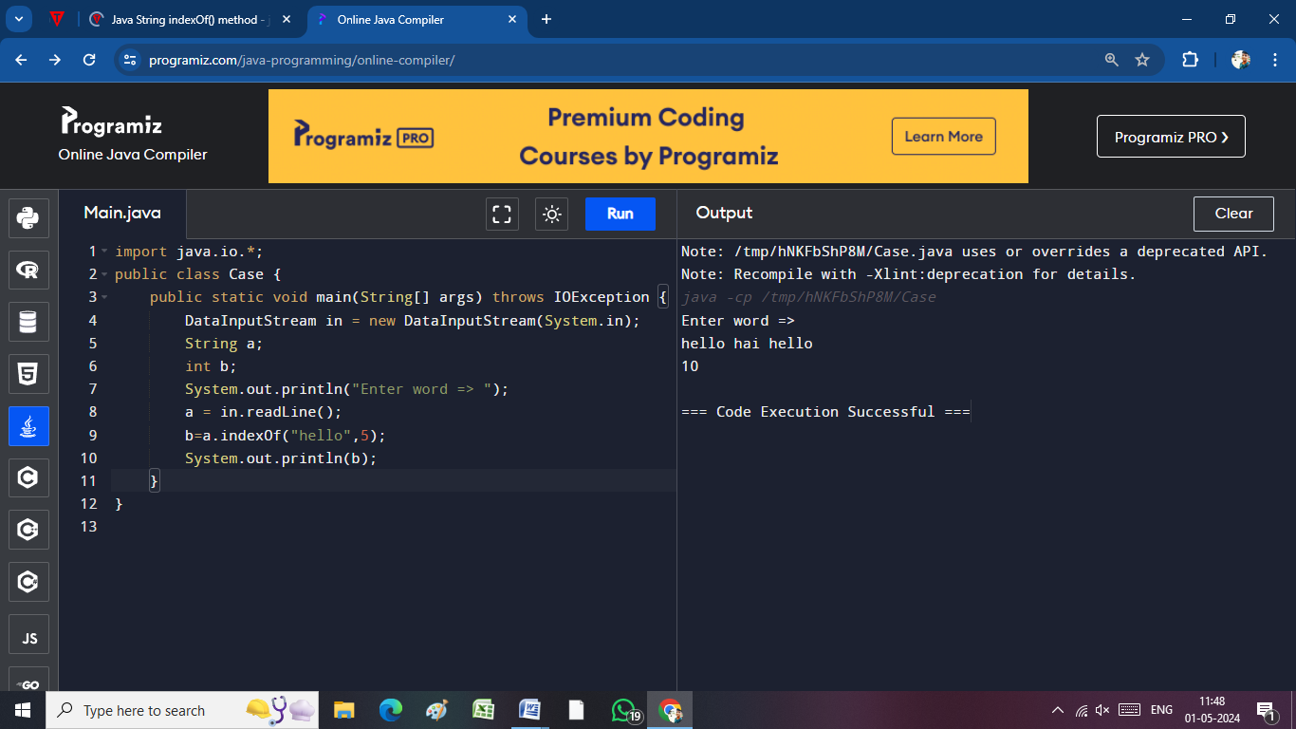 int b;

System.out.println("Enter word => ");

a = in.readLine();

b=a.indexOf("hello",5);

System.out.println(b);

}

}

[**String toLowerCase()**](https://www.javatpoint.com/java-string-tolowercase)**:**

import java.io.*;

public class Case {

public static void main(String[] args) throws IOException {

DataInputStream in = new DataInputStream(System.in);

String a,b;

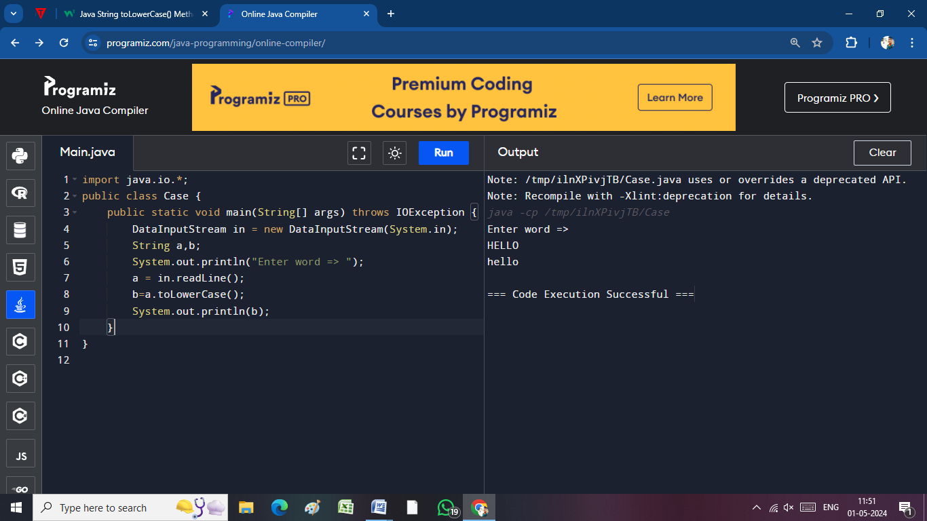 System.out.println("Enter word => ");

a = in.readLine();

b=a.toLowerCase();

System.out.println(b);

}

}

[**String toLowerCase(Locale l)**](https://www.javatpoint.com/java-string-tolowercase)**:**

import java.util.Locale;

public class StringtoLowerCaseDemo {

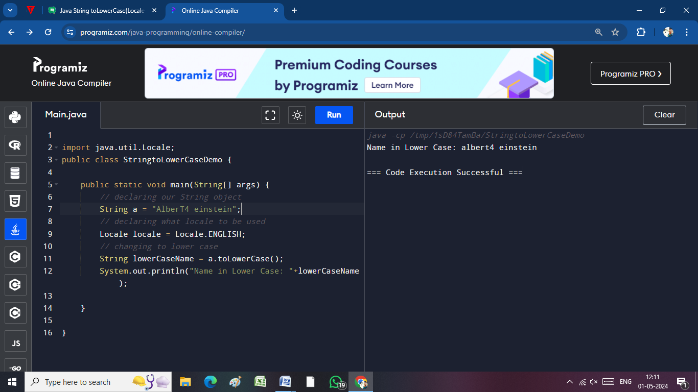

public static void main(String[] args) {

// declaring our String object

String a = "AlberT4 einstein";

// declaring what locale to be used

Locale locale = Locale.ENGLISH;

// changing to lower case

String lowerCaseName = a.toLowerCase();

System.out.println("Name in Lower Case: "+lowerCaseName);

}

}

[**String toUpperCase()**](https://www.javatpoint.com/java-string-touppercase)**:**

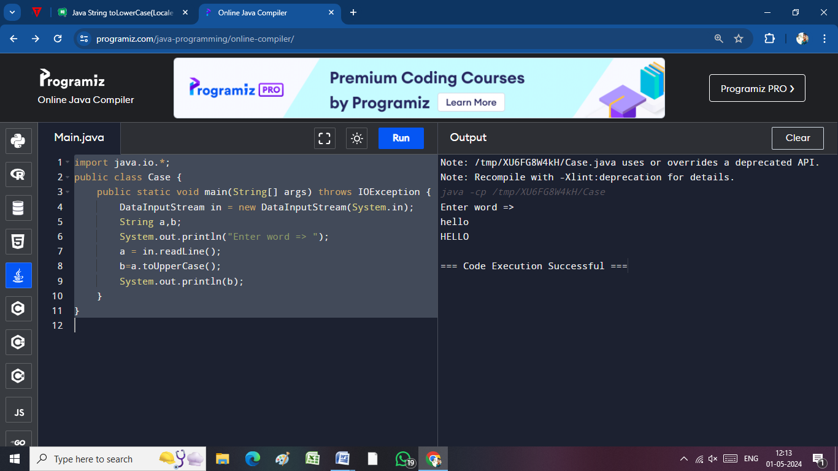import java.io.*;

public class Case {

public static void main(String[] args) throws IOException {

DataInputStream in = new DataInputStream(System.in);

String a,b;

System.out.println("Enter word => ");

a = in.readLine();

b=a.toUpperCase();

System.out.println(b);

}

}

[**String toUpperCase(Locale l)**](https://www.javatpoint.com/java-string-touppercase)**:**

import java.util.Locale;

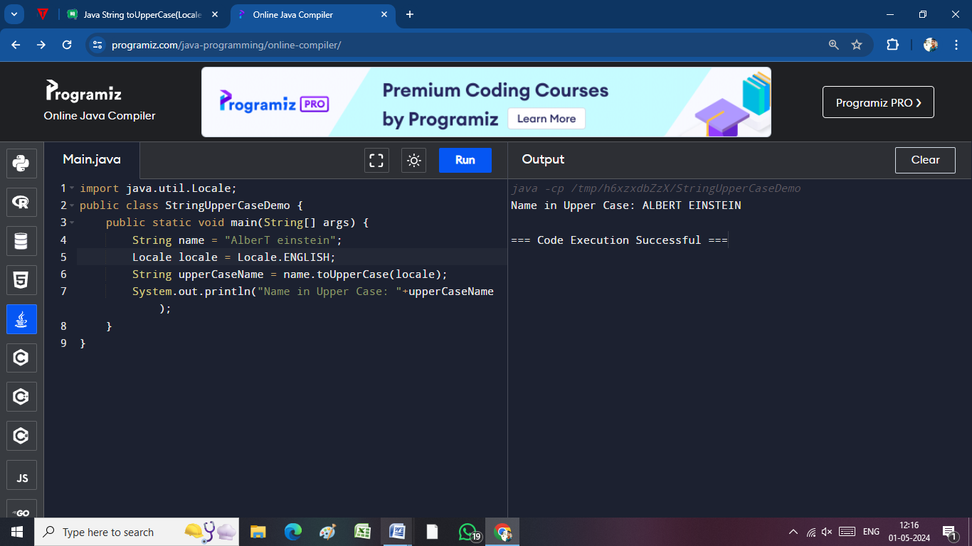public class StringUpperCaseDemo {

public static void main(String[] args) {

String name = "AlberT einstein";

Locale locale = Locale.ENGLISH;

String upperCaseName = name.toUpperCase(locale);

System.out.println("Name in Upper Case: "+upperCaseName);

}

}

[**String trim()**](https://www.javatpoint.com/java-string-trim)**:**

import java.io.*;

public class Case {

public static void main(String[] args) throws IOException {

DataInputStream in = new DataInputStream(System.in);

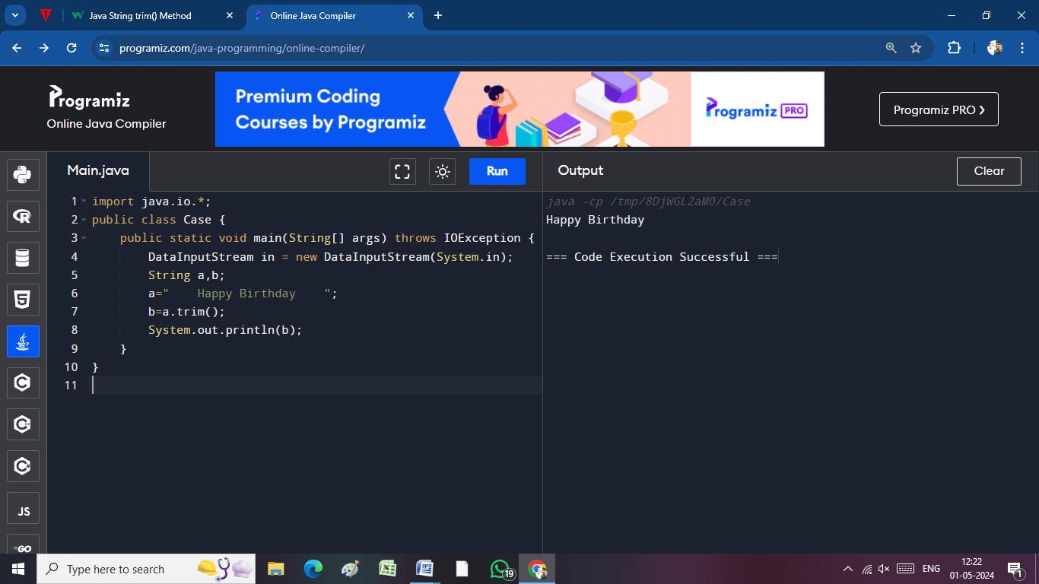 String a,b;

a=" Happy Birthday ";

b=a.trim();

System.out.println(b);

}

}

[**static String valueOf(int value)**](https://www.javatpoint.com/java-string-valueof)**:**

import java.io.*;

public class Case {

public static void main(String[] args) throws IOException {

DataInputStream in = new DataInputStream(System.in);

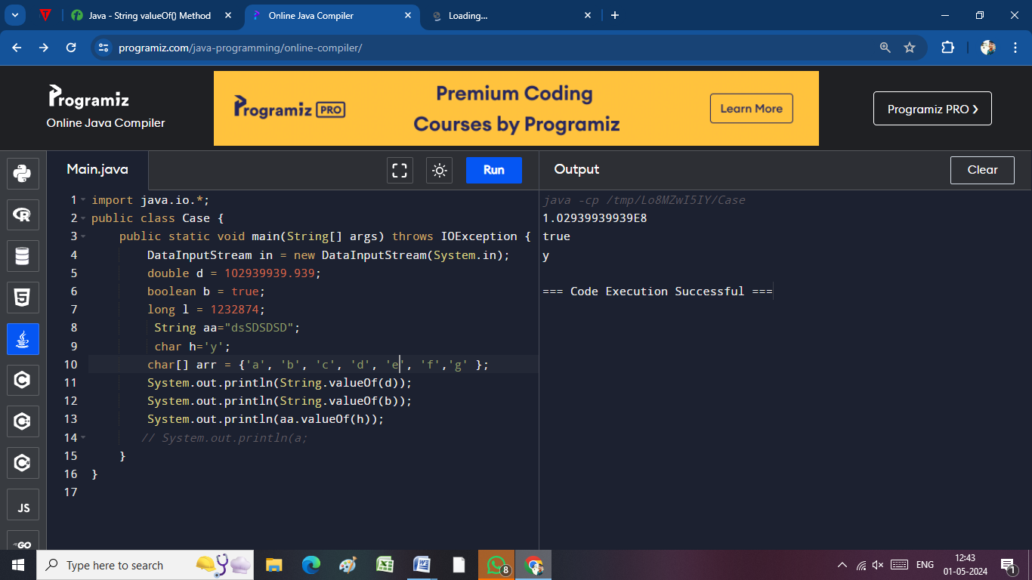 double d = 102939939.939;

boolean b = true;

long l = 1232874;

String aa="dsSDSDSD";

char h='y';

char[] arr = {'a', 'b', 'c', 'd', 'e', 'f','g' };

System.out.println(String.valueOf(d));

System.out.println(String.valueOf(b));

System.out.println(aa.valueOf(h));

}

}

**File concept:**

File is to read and write the data.

For Reading the file we use Reader() function.

For Writing the file we use Filewriter() funvction.

**OOPS:**

**Inheritance:**

**When one object acquires all the properties and behaviors of a parent object, it is known as inheritance.**

**Polymorphism:**

**It consist of two types :**

**i) Overloading:**

**It** **multiple methods in a class , which have the same names.**

But all the methods will be assigned with different parameters.

**ii) Overriding:**

In Java, method overriding occurs when a subclass (child class) has the same method as the parent class. In other words, method overriding occurs when a subclass provides a particular implementation of a method declared by one of its parent classes.

**Abstraction:**

It is used to hide or keep it something private until the function is called.

We use abstract class for abstraction.

**Encapsulation:**

Binding the data together into a single class is called Encapsulation.